Logo: Disability Business Network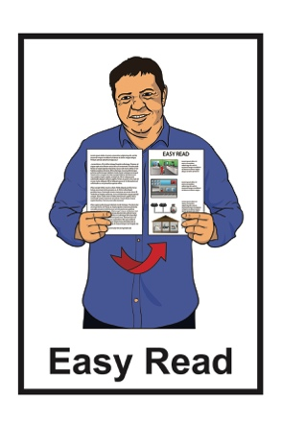

# Logo: CCS Disability Action

My Business Starter -

A course about how to set up your own business

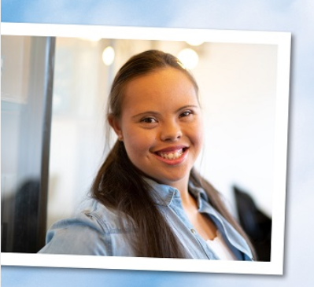

# My Business Starter



This is an Easy Read information about the **My Business Starter** course.

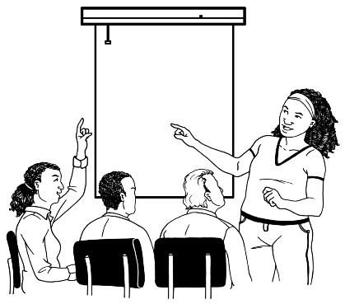**My Business Starter** is a **course** for disabled people who want to start their own business.

A **course** is where you learn the things you need to know about setting up a business / work idea.



It is a good course to do if you:

* 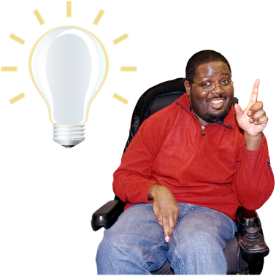want to work for yourself
* have an idea for a business
* want to find out if your business idea is a good one.

# Who runs My Business Starter?



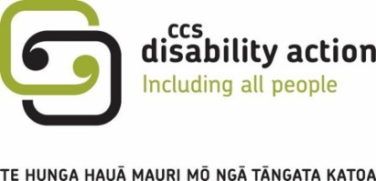The **Disability Business Network** runs My Business Starter alongside CCS Disability Action.

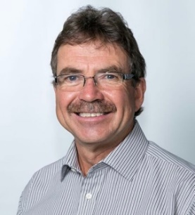

There are 3 people who run the Disability Business Network.

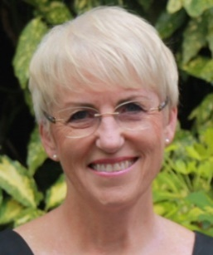

They are:

* Selwyn Cook

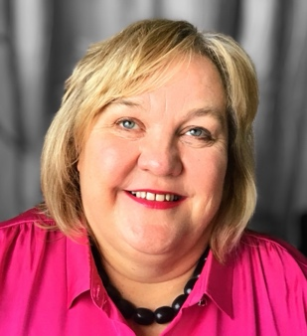

* Sandra Budd
* Julie Woods.

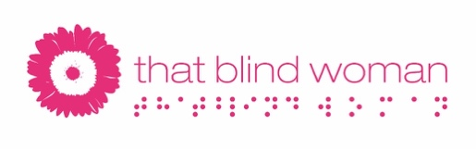Julie Woods has a **website** called **That blind woman:**

[**www.thatblindwoman.co.nz**](http://www.thatblindwoman.co.nz)

# What do you learn in the course?



In the course you learn how to:

* get your business started
* manage money for your business

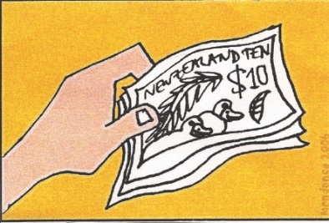

* find **customers**
* sell to **customers.**



**Customers** are people who want to buy from your business.

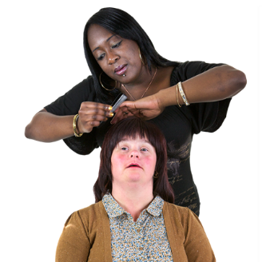Customers pay you to buy your:

* **products**
* **services**.

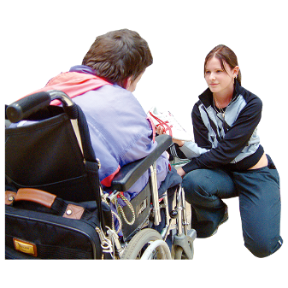**Products** are things you make or have that people can buy.



For example:

* making / selling clothes



* making / selling food
* growing / selling flowers.

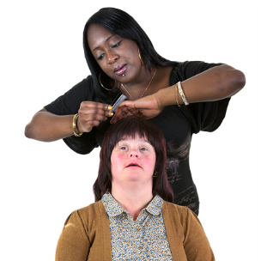

**Services** are things you do for someone.

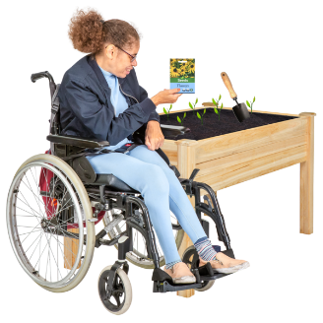For example:

* hairdressing
* 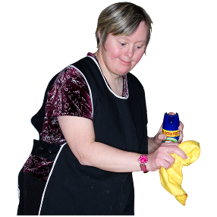gardening / mowing lawns
* cleaning.

# What do you do on the course?



On the course you:

* Circle

  Description automatically generated with low confidencewrite a short business plan
* work out what your product or service is
* talk to a **coach** between each lesson.

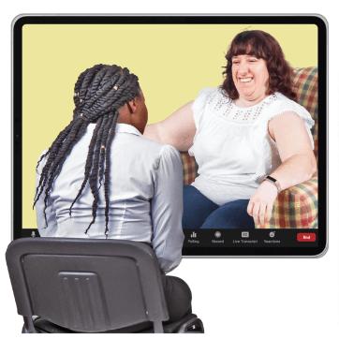A **coach** is someone who will:

* talk with you about your ideas
* support you to write your business plan.

****At the end of the course you decide if you want to:

* start a business
* not start a business.



When you do the My Business Starter course you can also:

* become a member of the Disability Business Network for 1 year
* 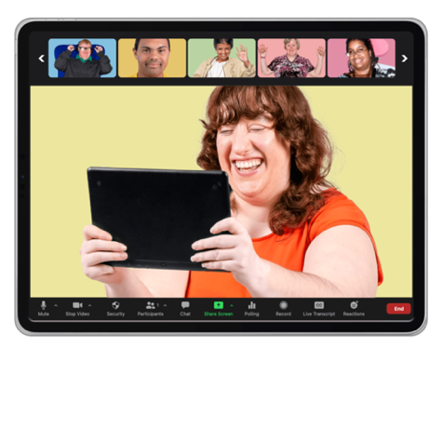get to know other Disability Business Network members
* can share your stories / experiences with other members.

# How do I do the course?



You do the course using **Zoom**.

**Zoom** is a way of talking to people online.

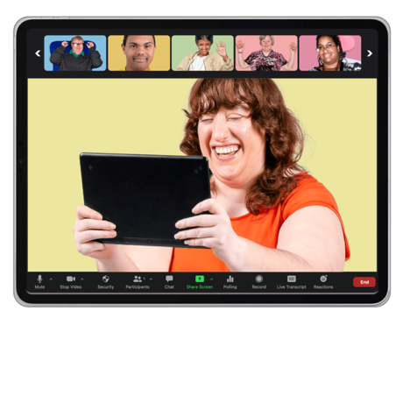

By using Zoom you can:

* see / hear your tutor
* ask questions.

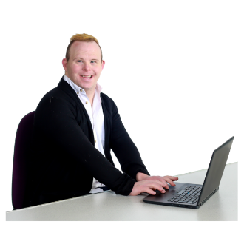

You do the course using a:

* 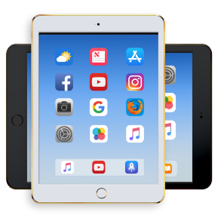computer / laptop
* iPad / other tablet.

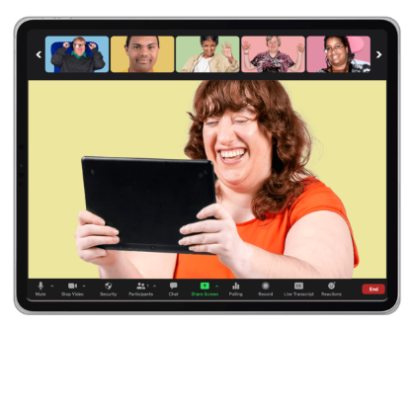The course has:

* 5 lessons
* 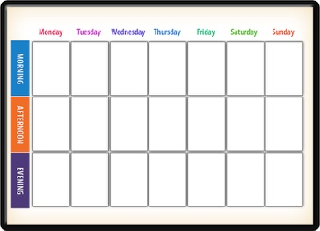2 weeks between each lesson
* times to talk to a coach between each lesson.

# Where to find more information

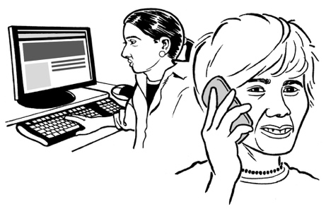

Please get in touch with CCS Disability Action if you want more information.



Email:

**support@ccsDisabilityAction.org.nz**



Website:

**www.ccsDisabilityAction.org.nz**

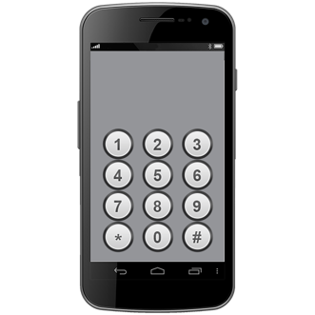

Phone:

**0800 227 2255**

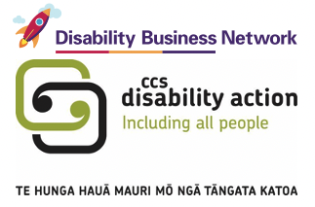This information has been written by the Disability Business Network and CCS Disability Action.

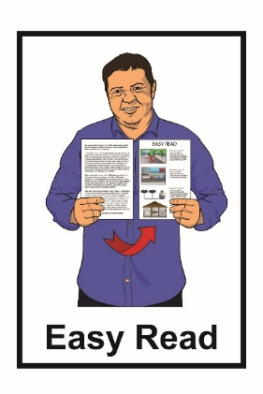

The Make it Easy service of People First New Zealand Inc. Ngā Tāngata Tuatahi. translated it into Easy Read.

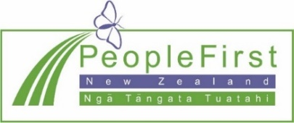The ideas in this document are not the ideas of People First New Zealand Inc. Ngā Tāngata Tuatahi.

Change logo.
Change is the name of the organisation.Make It Easy uses images from:

* Changepeople.org
* Photosymbols.com



* SGC Image Works
* Huriana Kopeke-Te Aho.

All images used in this Easy Read document are subject to copyright rules and cannot be used without permission.