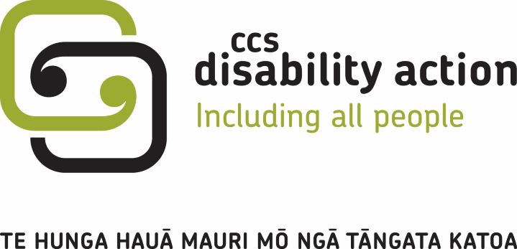
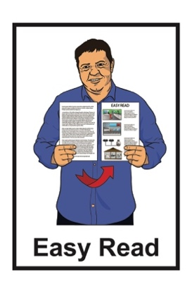

Our Strategic Priorities

Mahere Rautaki

2022 to 2025
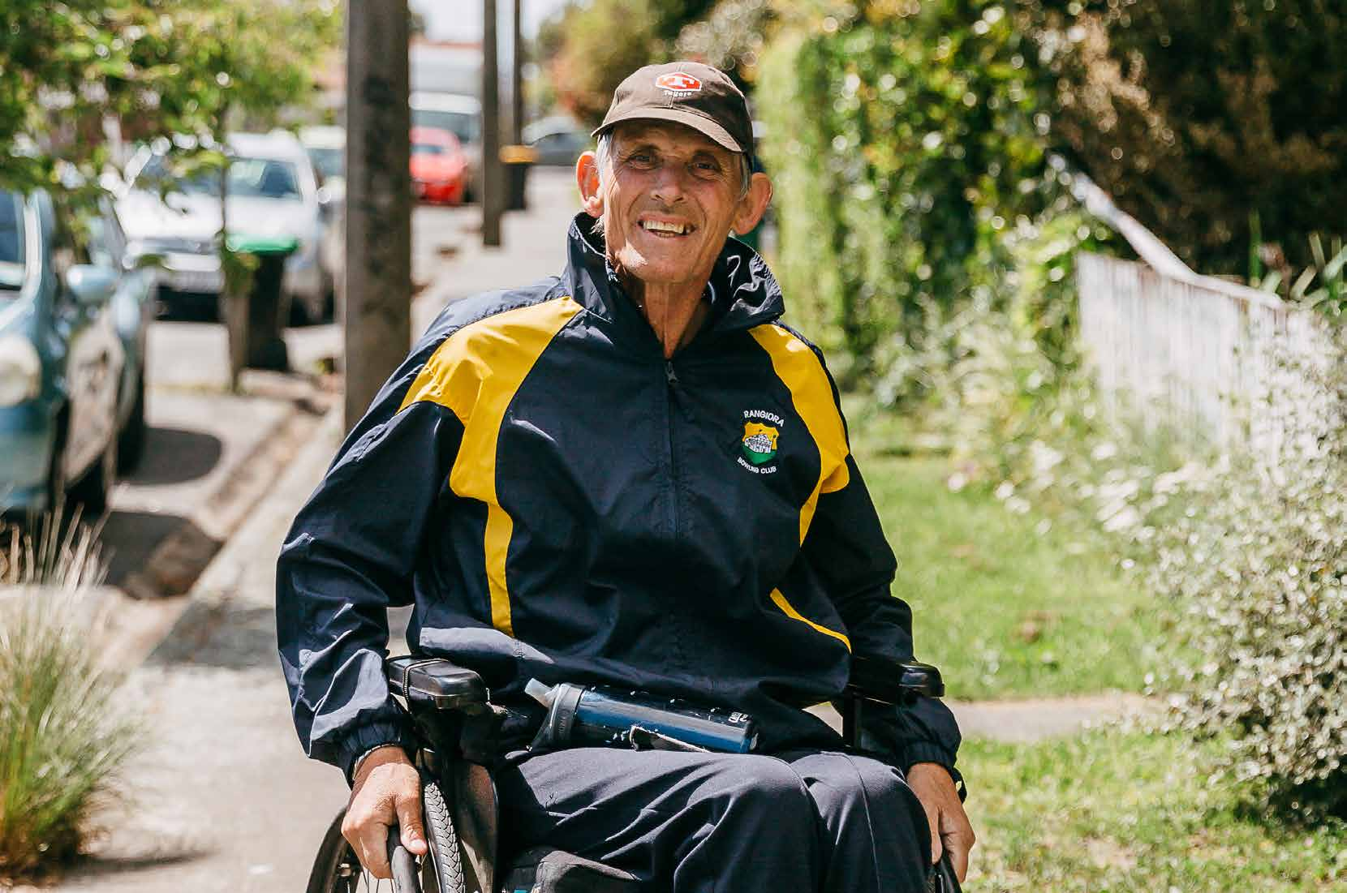

Published: June 2023

What you will find in here

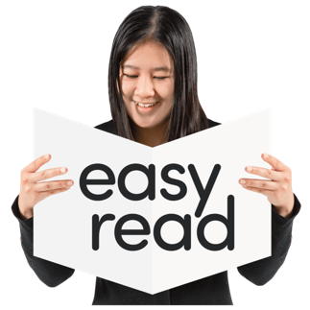
Page number:

About this document 3
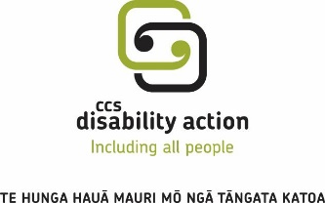

About CCS Disability Action 5

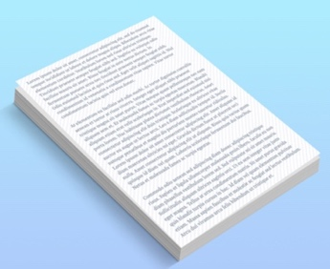

Our foundation statement 8

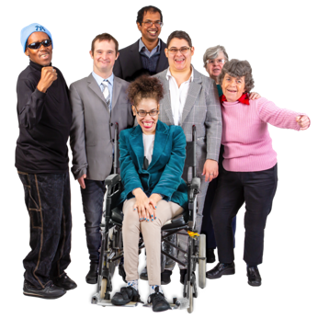

Our challenge 10

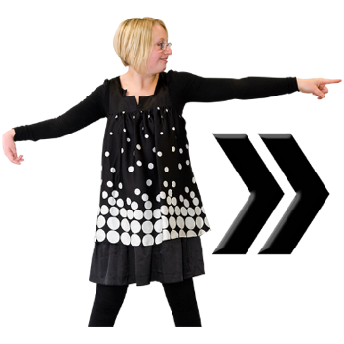

Our vision 13

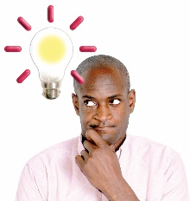
Page number:

What are our strategic priorities? 16

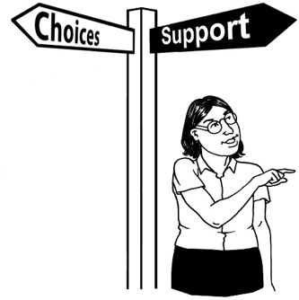

What we will do 27

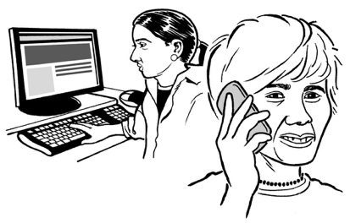
How to contact us 30

About this document

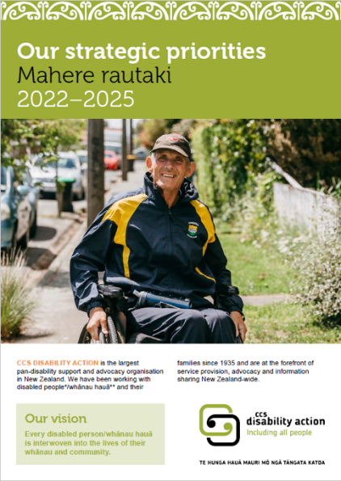
This is an Easy Read summary of the CCS Disability Action Strategic Priorities 2022 to 2025.

A summary is a short version of a document.

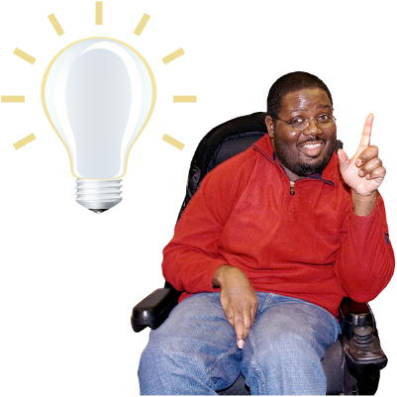
Strategic Priorities are the values / ideas that guide:
- how CCS Disability Action works
- the work that CCS Disability Action does.

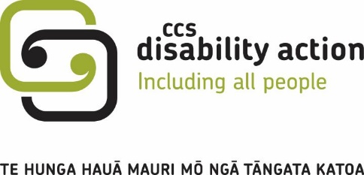
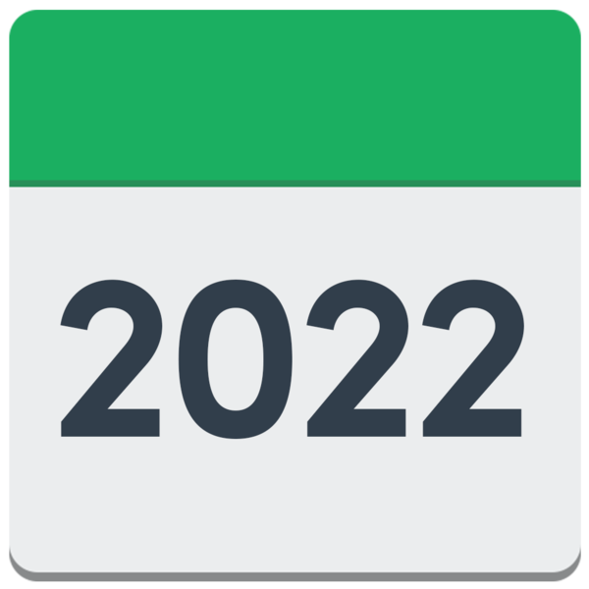
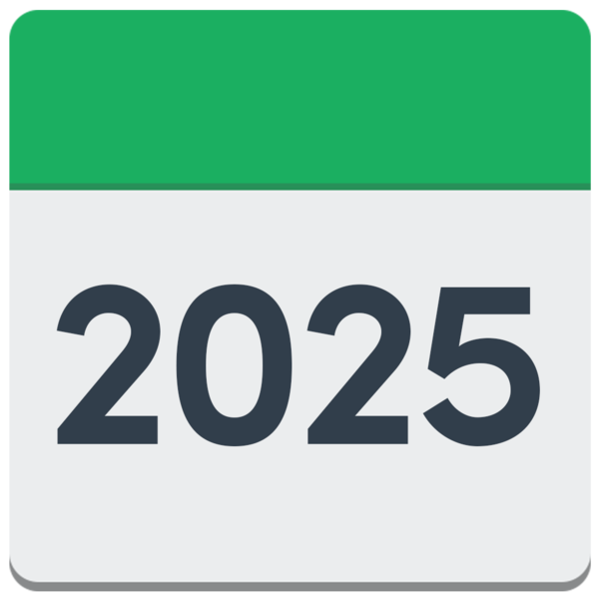
When you see the word we used in this summary it means CCS Disability Action.
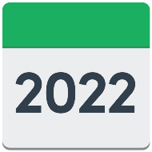
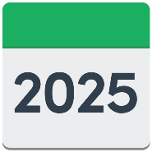
The strategic priorities will tell CCS Disability Action what to do:
from 2022
to 2025.

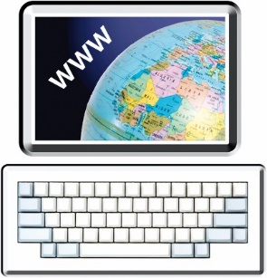
You can find the full document about the strategic priorities on the CCS Disability Action website at:

www.ccsdisabilityaction.org.nz/strategic-priorities

About CCS Disability Action

CCS Disability Action began in 1935.

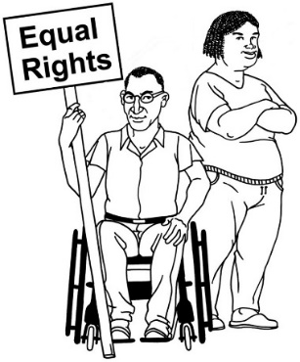
We work to make the lives of disabled people / whānau hauā better.

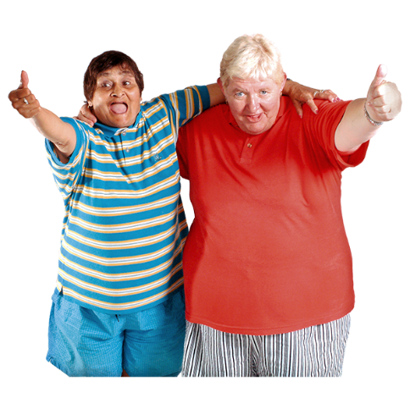
We use the words whānau hauā to describe a disabled person who feels a sense of belonging with a group of people of their own choosing.

This group of people might be:
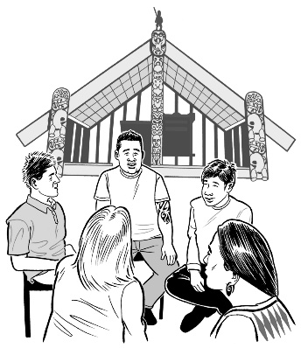
- whānau / family
- iwi /hapū
- community groups.
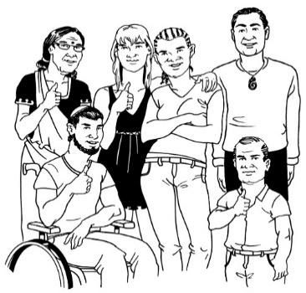
We support people of all:
ages
disabilities
cultures.
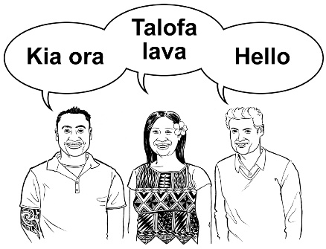

Culture is a way of:
thinking that a group shares
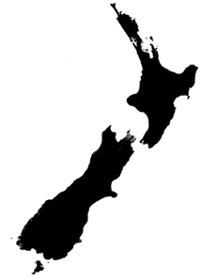
doing things as a group.

There are many different cultures in Aotearoa New Zealand.

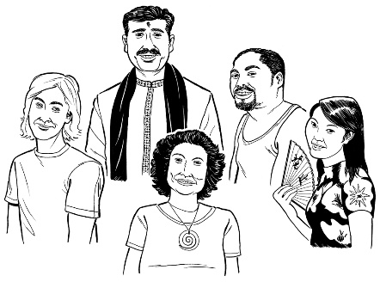
Some examples of the different cultures are:
Māori culture
Pasifika culture
Deaf culture.

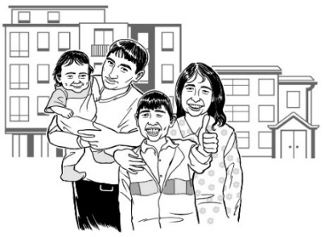
CCS Disability Action works with lots of different groups including:
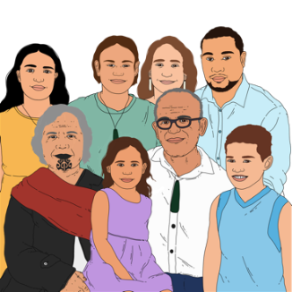
disabled people
the whānau / family of disabled people
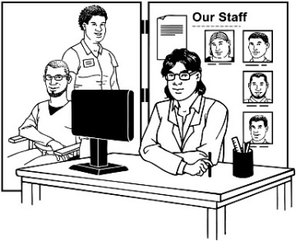
iwi / hapū
support services
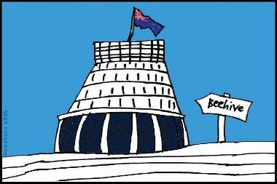
education like schools / colleges
the New Zealand Government.

Our foundation statement

A foundation statement is the main idea that a group is built on.

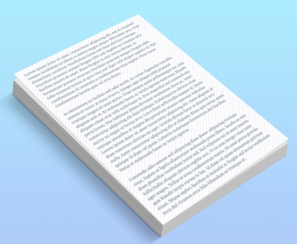
Our foundation statement says:
who we are
- what we believe.

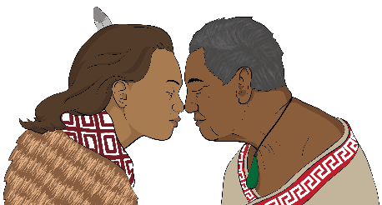
Our foundation statement is a saying written in te reo Māori:

Te hunga hauā mauri mō ngā tāngata katoa.

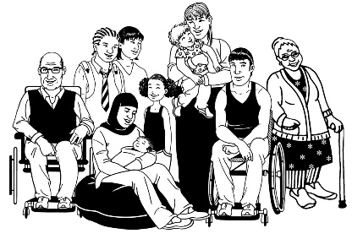
Our foundation statement means:
everyone has a special life force called mauri
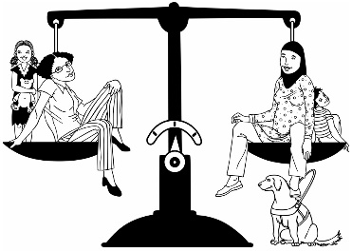
we believe that every person is equally important to us.

Our challenge

1 out of 4 people in New Zealand have a disability / impairment.

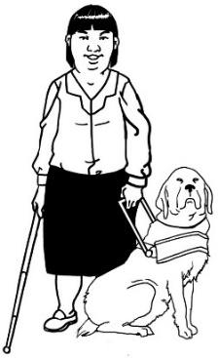
The word impairment is used when your body or brain has a hard time doing some things.

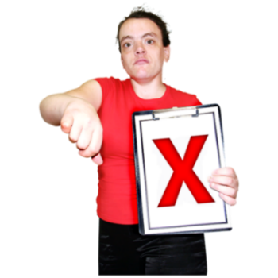
Sometimes there are barriers that stop disabled people from being included in the community.

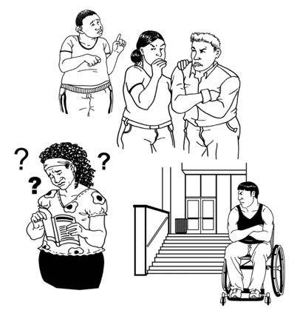
Barriers are things that make it harder for disabled people to live a good life.

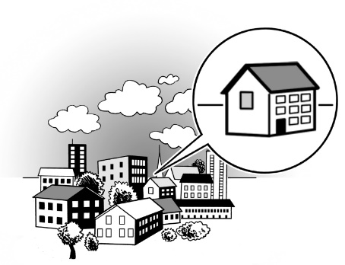
A community is a group of people that share something in common.

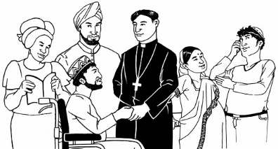
This means things like:
living in the same area / neighbourhood
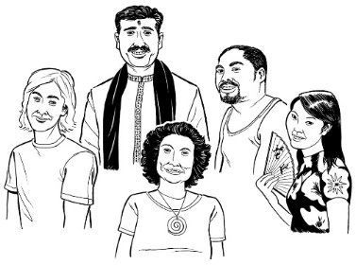
being part of the same religion
sharing the same culture / values.
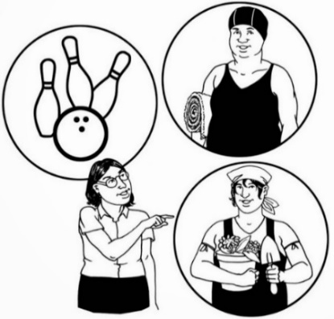

When disabled people are a part of the community it makes things better for everyone.
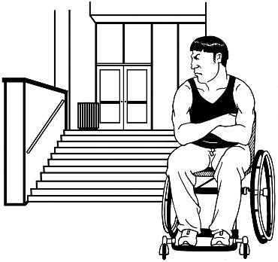
Some of the barriers that stop disabled people from being included are:
the way that buildings are made
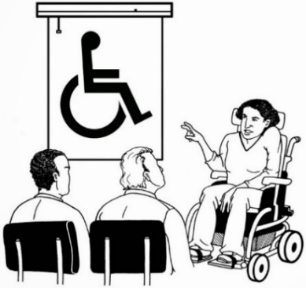
what people think about disability
information that is hard to understand
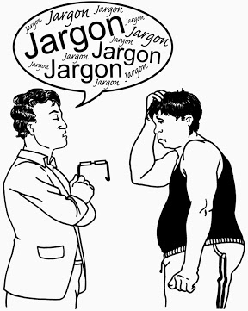
not having access to the things / the support they need to have a good life.

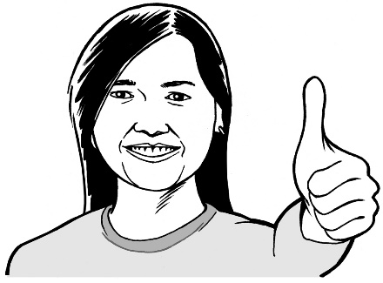
CCS Disability Action wants to get rid of barriers so all disabled people can:
be included
have a good life.

Our vision

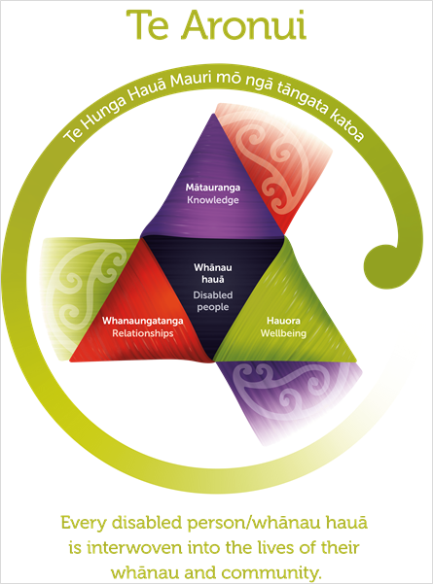

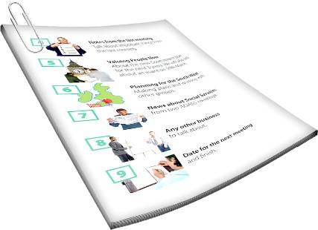
We will look at what the words in this image mean on pages 14 to 26.

Vision means how we want the world to be for disabled people in the years to come.

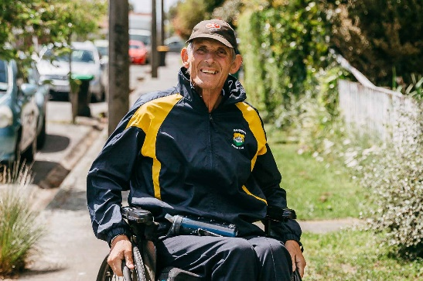
Our vision is that every disabled person / whānau hauā is interwoven into the lives of their whānau and community.

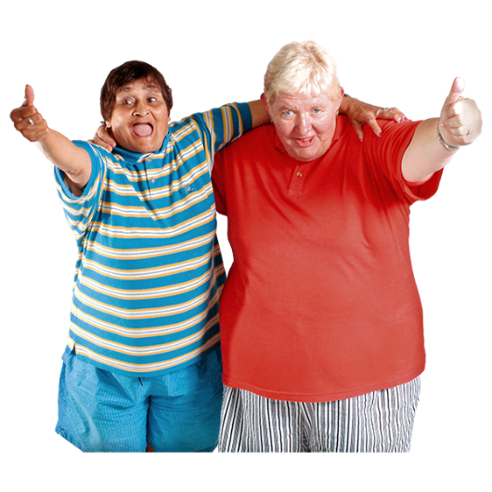
Interwoven means to be a fully a part of something whether than be your:
- whānau / family
- community

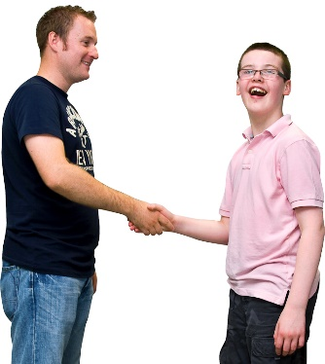
Aronui is important to way we work now and in the years to come.

Aro means to face or turn towards.

Nui means is the great space.
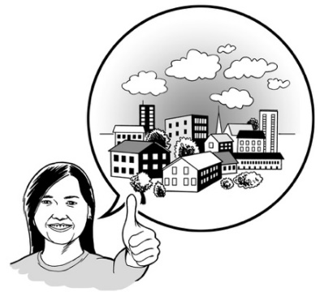

For us aronui means:
- the connections we all have with the world around us
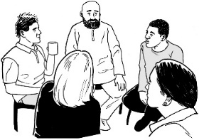
- working alongside:
  - the people we support
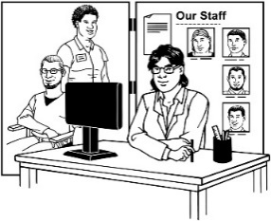
  - each other
  - other organsiations.

What are our strategic priorities?

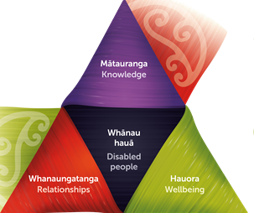
Our strategic priorities focus on 4 important things:

- Whānau hauā – Disabled people

- Mātauranga – Knowledge

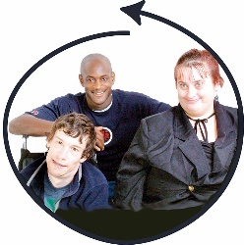
- Whanaungatanga – Connectedness

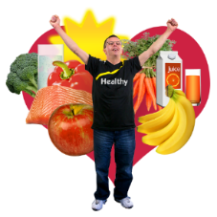
- Hauora – Wellbeing.

Whānau hauā– Disabled people

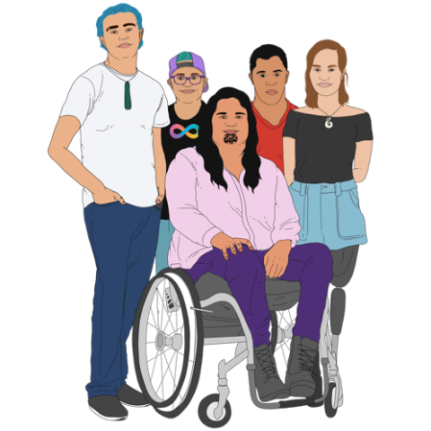
Disabled people are our:
purpose
focus.

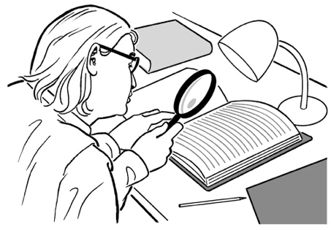
Purpose means why we do what we do.

Focus is when we look at the things that are the most important to us.

These 2 things are the values that make up Aronui.

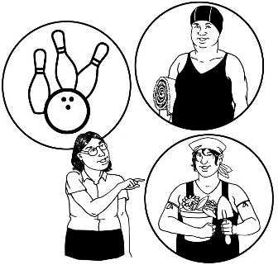
Focusing on disabled people reminds us to make sure everything we do is guided by what disabled people:
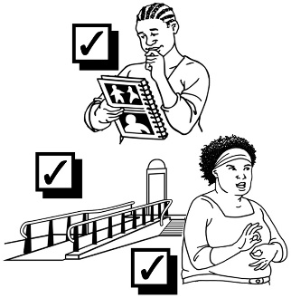
want
need.

2. Mātauranga – Knowledge

Knowledge:
is what we know / understand
comes from the things we do / go through in life.
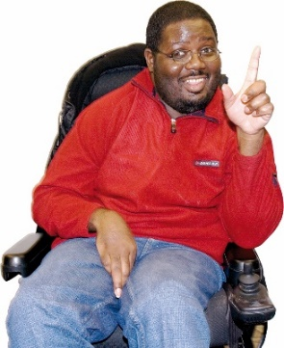

Knowledge helps us to:
do things in our lives
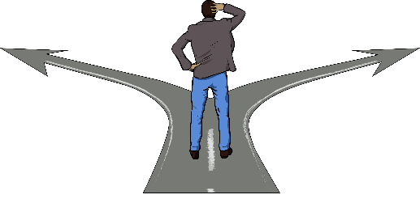
learn from the things we do
make sense of the things around us.

All people have knowledge that can make things work better.

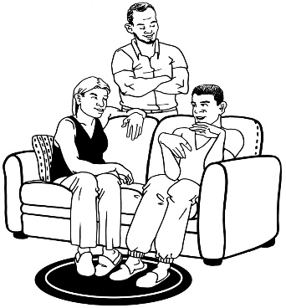
We know that:
disabled people / their whanāu know the most about their own lives
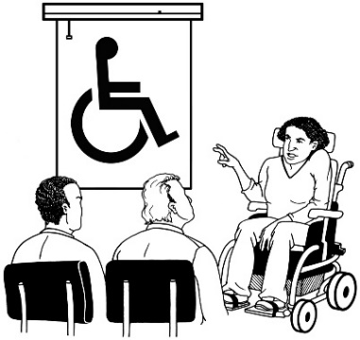
we can learn how to make things better by listening to what disabled people tell us.

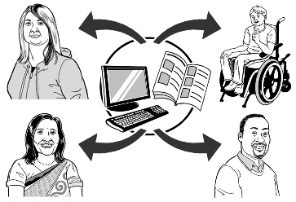
We will share our knowledge with everyone so disabled people can find the information that they need.

3. Whanaungatanga –Connectedness

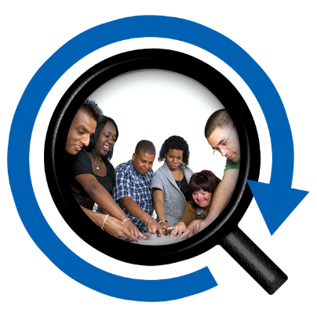
Connectedness means knowing that there are connections between:
all people
all systems.
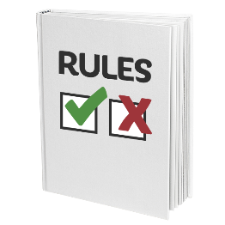
Systems means the different parts of a community that work together to make things happen.

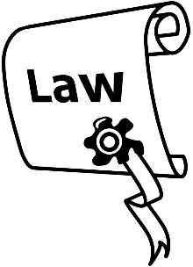
Systems can include:
groups / organisations
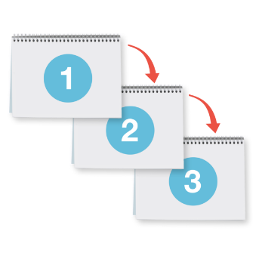
rules / laws
the steps that are taken to get things done.
CCS Disability Action makes sure disabled people can connect to systems that will support them with the resources they need.
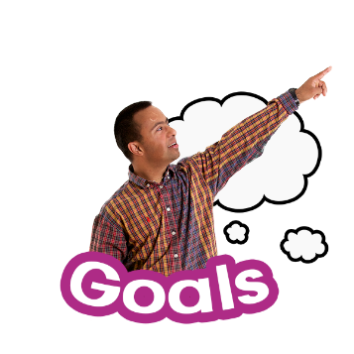

Resources are things that we can use to help us:
do different tasks
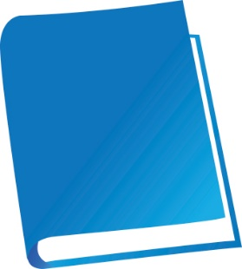
reach our goals.

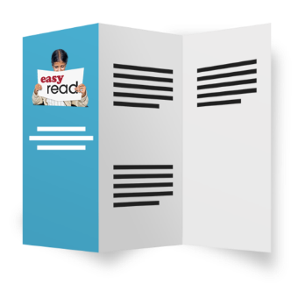
Resources can also be used to give information like:
- books
- leaflets
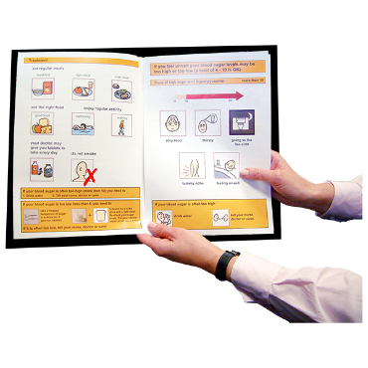
- posters
- instructions manuals which tell us how to do things.
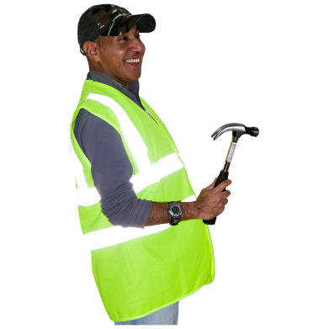
Resources can also be things that support us to live our lives like:
tools
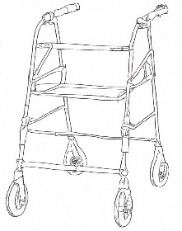
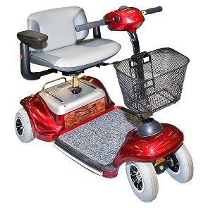
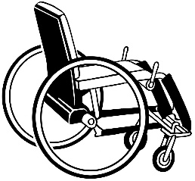
equipment like:
- wheelchairs
- walkers
- disability scooters.

It is important that CCS Disability Action understands the links between:
people
systems.

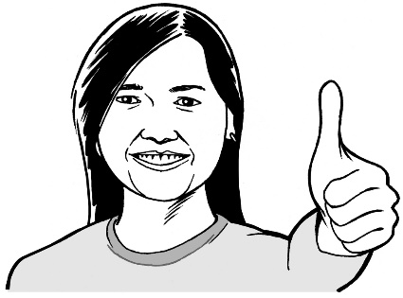
When we understand how all these things connect we can make sure disabled people can get what they need.

4. Hauora – Wellbeing

Wellbeing is about:
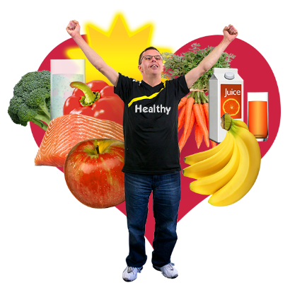
taking care of yourself
doing things that makes you feel healthy in:
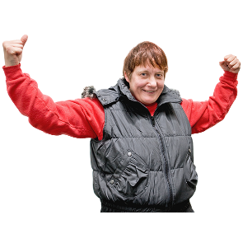
- your body
- your mind.

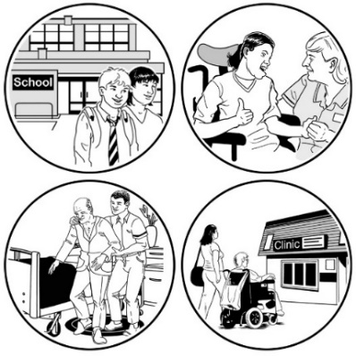
CCS Disability Action focuses on wellbeing because they know that being well means different things for each person.

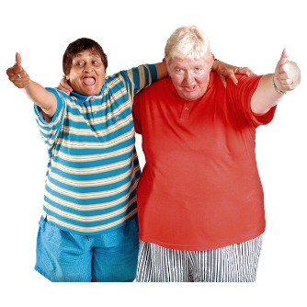
Wellbeing may be things like:
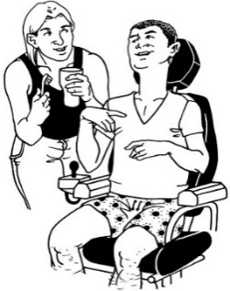
being with friends or family you are close to
having things to do in your life that you enjoy
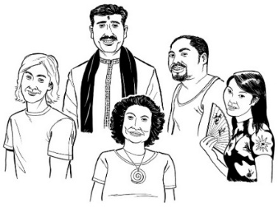
having a place to live where you feel happy
being able to be part of your culture
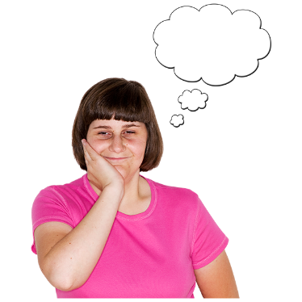
being able to decide what is important to you.

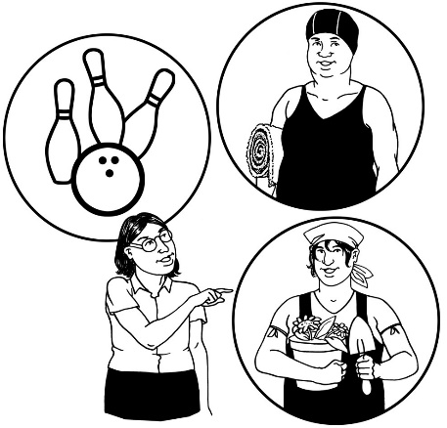
To support wellbeing CCS Disability Action will make sure that:
disabled people have a say in how they live their lives
they will guide disabled people to lead their lives in a way that suits them best.

What we will do
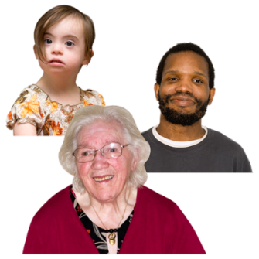

CCS Disability Action will work hard to make sure disabled people / their whānau have access to:
information
resources
support.

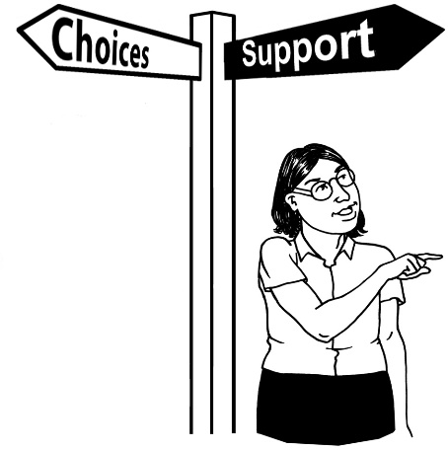
We think it is important for disabled people / their whānau to have access to:
what they need
when they need it.

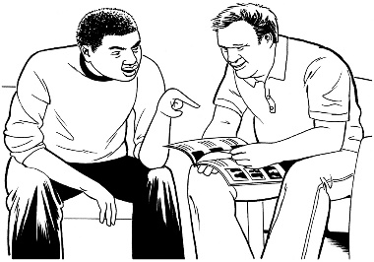
This might be things like
information
resources
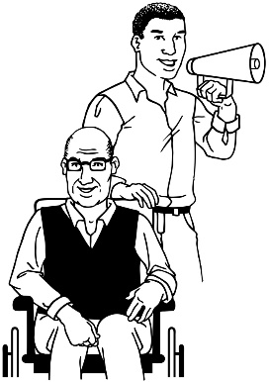
support
advocacy.

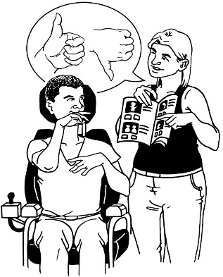
Advocacy is when somebody:
speaks up for you
makes sure you get to have your say
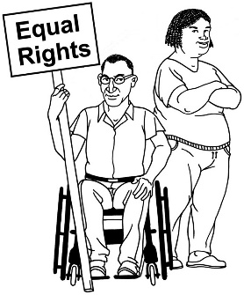
supports you to make choices about what happens in your life
makes sure you are treated fairly.

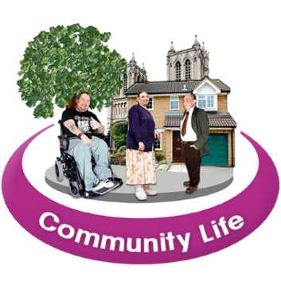
CCS Disability Action will work to make the community better for disabled people.
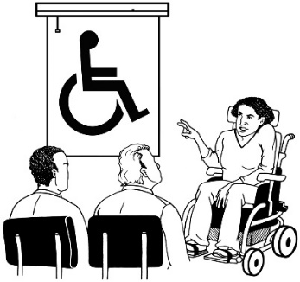

We will do this by supporting the community to:
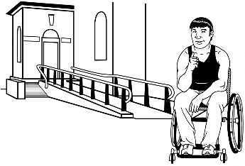
learn more about disability
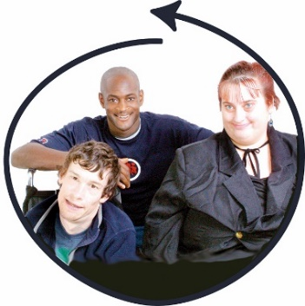
get involved to make things better for disabled people
make places easier to access
include disabled people in decisions
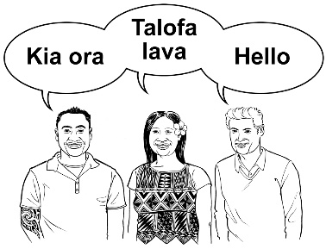
be welcoming to all people.

How to contact us
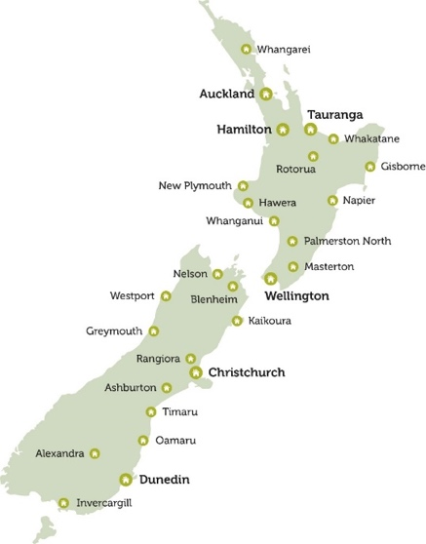

CCS Disability Action has offices in lots of places in New Zealand.

You can find out which CCS Disability Action office is close to you by:
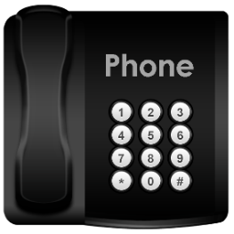
calling us on:

0800 227 220
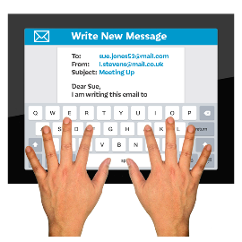
sending us an email to:

Info@ccsDisabilityAction.org.nz

You can also get in touch with us by posting a letter to:

PO Box 6349

Wellington 6141

You can also find us online on our:
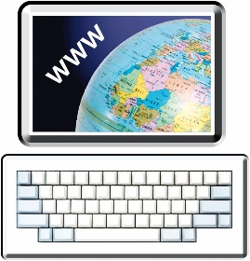
website:

www.ccsDisabilityAction.org.nz

Facebook page:

www.facebook.com/ccsDisabiliyAction

Twitter page:

www.twitter.com/ccsDisabilityAction

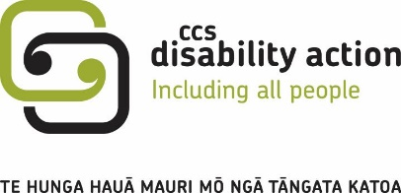
This information has been written by CCS Disability Action.

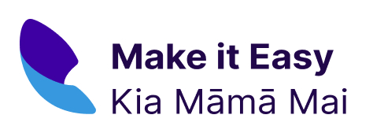
It has been translated into Easy Read by the Make it Easy Kia Māmā Mai service of People First New Zealand Ngā Tāngata Tuatahi.

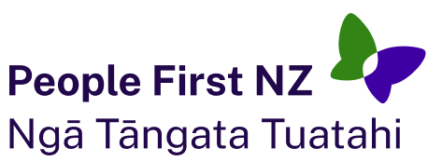
The ideas in this document are not the ideas of People First New Zealand Ngā Tāngata Tuatahi.

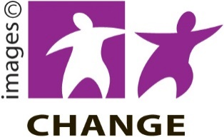
Make it Easy uses images from:
- Changepeople.org

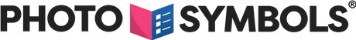
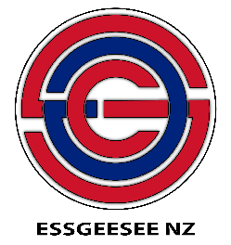
- Photosymbols.com

- SGC Image Works

- Huriana Kopeke-Te Aho.
All images used in this Easy Read document are subject to copyright rules and cannot be used without permission.

