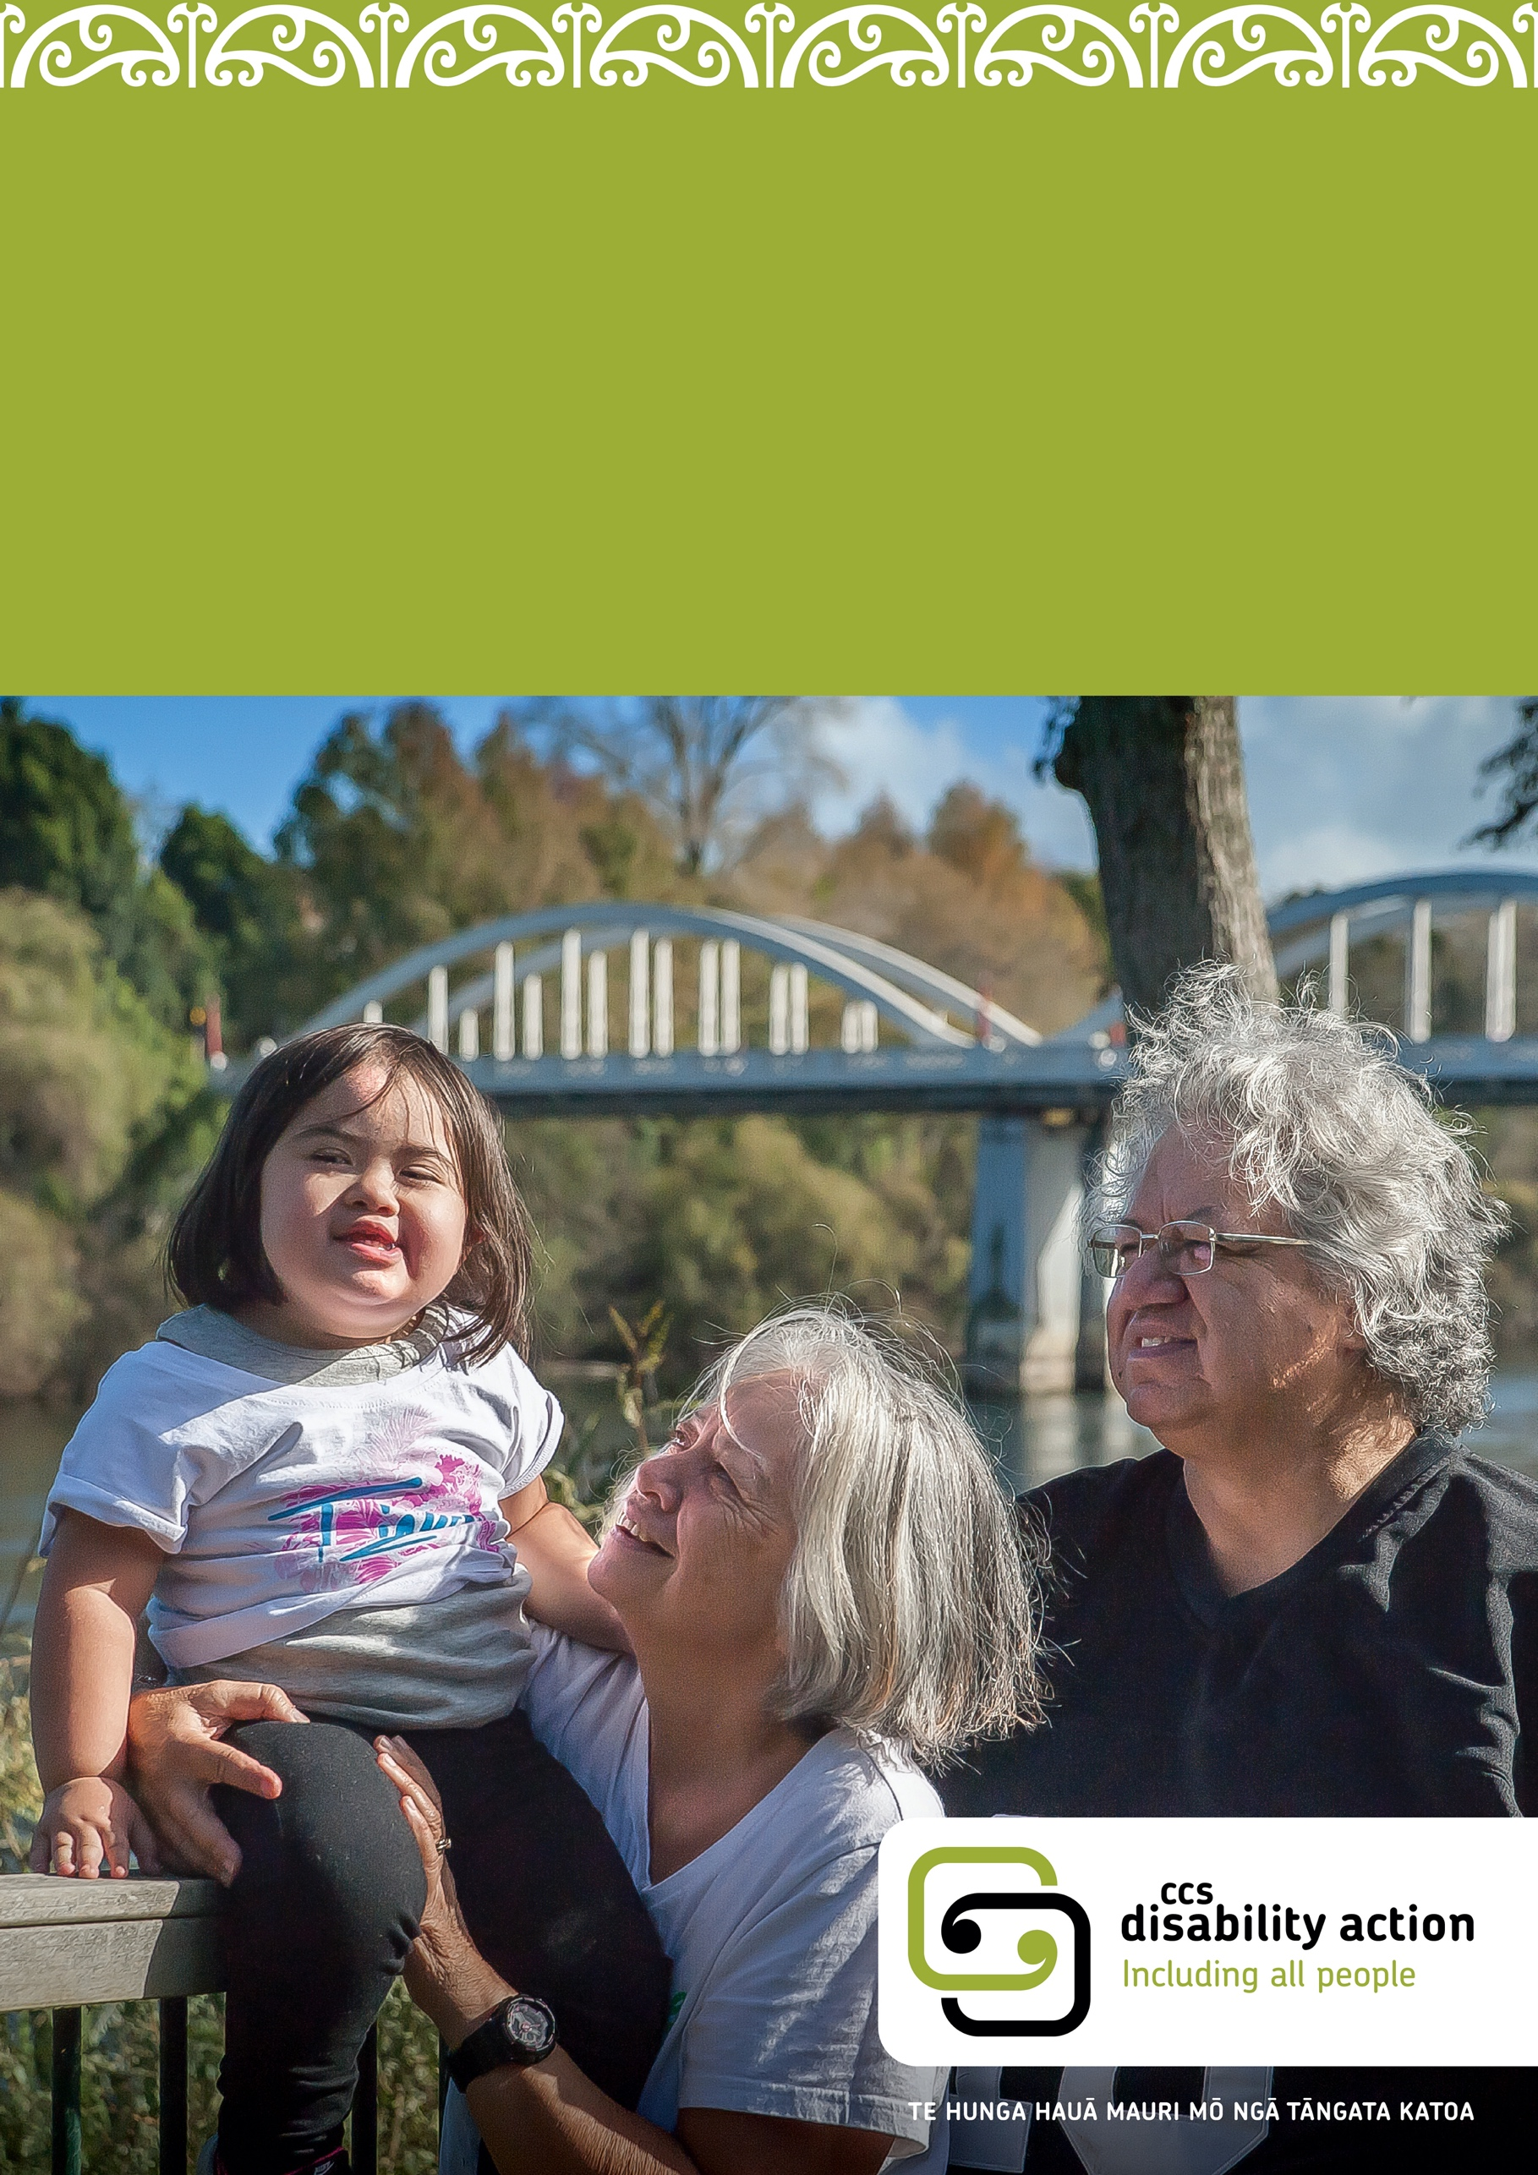
Caregivers’ manual
Oranga Tamariki services
Information, policies, and procedures for caregivers

Contents
Caregivers Manual Oranga Tamariki Services
1. How to use this manual 4
2. Thank you 5
3. Who we are 6
Our foundation statement 6
What we value 6
Our work 7
Te Tiriti o Waitangi and the Treaty of Waitangi 7
How we work with people 7
Your Coordinator 8
Important phone numbers 10
CCS Disability Action emergency duty phone guidelines 10
4. Your role as a CCS Disability Action caregiver 12
Your role 12
Immediate reporting 13
Routine reporting 13
The privacy of the tamaiti/rangatahi you support 14
Guardianship 15
Access/contact with natural family 16
Health and medical 17
Consent for medical and dental treatment 17
Not-for-resuscitation orders 18
Death of a tamaiti/rangatahi in care 18
Child protection – abuse and neglect 19
Visitors 19
Keeping yourself safe 19
Allegations of abuse 19
Complaints 20
Behaviour support; managing challenging behaviour 21
Restraint minimisation 22
Damage to property and insurance 22
5. What you can expect from us 23
Recruitment and screening 23
Caregiver orientation and training 24
Caregiver support 25
National Care Standards 25
Caregiver Support Plan and All About Me plan 25
Board payments 26
Financial reimbursements 26
Siblings 27
Culture, language and religion of the child/young person 27
6. Health and safety 28
Incident reporting 28
Hazard control 28
Quarterly audits 28
Annual health and safety audit 29
Fire safety 29
Civil defence 29
Providing a smoke-free and illegal drug-free household 29
7. Other people who may support the tamaiti/rangatahi 30
Oranga Tamariki – Ministry for Children 30
Disability Support Services 30
8. Further information checklist 31
9. Signed statement 32

Caregiver Training Information 33
Links for accessing support 35
First aid training 35
Crisis prevention 35
Understanding trauma and informed practice 35
Safeguarding child protection 35
Caring for families 36
Connecting the disabled community 36
Fetal alcohol spectrum disorder 36
Autism 37
Attention deficit hyperactivity disorder 37
Down syndrome 38
Cerebral palsy 39
Cystic fibrosis 39
Kidney issues 40
Muscular dystrophy 40
Deafness 40
Rare disorders 41
Williams syndrome 41
Blind/visual impairment 42
Fostering and Residential Care 42

How to use this manual
Kia ora and welcome.
This manual has been written for you, a caregiver for a tamaiti/rangatahi we support. The manual contains information, policies, and procedures specific
to your role and the child in your care and other information we think you
may find useful.
Please read this manual and sign the last page. Before signing, make sure that you have discussed any of your questions or concerns with your Coordinator. You can always ask us questions about this manual as well as make suggestions to improve it.
Welcome and we look forward to working alongside you.

Thank you
Tamariki and rangatahi (children and young people) belong in families. They have a right to live with their family/whānau and to be safe from harm.
When the young person is no longer able to live with their whānau (for whatever reason), Oranga Tamariki the Ministry of Children has a responsibility to ensure that the tamaiti/rangatahi (child/young person) is safe and nurtured. This is when you may be needed.
Tamariki and rangatahi who are taken into the care of Oranga Tamariki, or who can no longer be cared for by their family/whanau, have often experienced stress and trauma. They have also been separated from their family and placed in an unfamiliar environment. They need love, security, and a safe place. They need to be able to build trust and resilience with an adult who understands and can meet their needs. We have approved you as a caregiver because we believe you can provide this for a tamaiti/rangatahi.
We hope the experience is enriching and rewarding not only for the tamaiti/rangatahi in your care but also for you and your family. We value you and we thank you for committing yourself to providing a caring and stable home for a tamaiti/rangatahi.

Who we are
CCS Disability Action is a community organisation that has been advocating for disabled people to be included in the community since 1935.
We are the largest pan disability provider in Aotearoa, and we provide a variety of different supports and services to children/young people, adults and their whānau. We have 17 branches across the country which operate from Northland to Invercargill. Our support focuses on breaking down barriers to participation and supporting people to live the life that they want. We receive a mixture of government and private funding.
You can read more about us on our website: http://www.ccsdisabilityaction.org.nz/
You will receive a dedicated login to our Caregiver portal, which you access via our website. This holds all the information contained in this manual and hosts extra information about news and opportunities from CCS Disability Action.

Our foundation statement
Te hunga hauā mauri mō ngā tāngata katoa
This statement forms the foundation of our identity and means that all people have Mauri, unique life force, and that we value every person equally.

What we value
- Mauri, the unique life force of each person.
- Disabled peoples’ leadership.
- The connections of family, whānau and community.
- The common ground between us and also our differences.
- The allies and partners in our work.

Our work
Three core documents guide our values:
- United Nations Convention on the Rights of Persons with Disabilities
- Te Tiriti o Waitangi
- New Zealand Disability Strategy
These documents mean we work within a human rights framework. We partner with disabled people, their families and whānau, to ensure that people with disabilities are in the driver’s seat in their lives, have a positive and connected life, and that their local communities are more inclusive.

Te Tiriti o Waitangi and the Treaty of Waitangi
Te Tiriti o Waitangi is a core document for CCS Disability Action. Te Tiriti o Waitangi is the Māori version of the Treaty, and it differs from the English version. Even though the two treaties are different, collectively the Treaty of Waitangi and Te Tiriti o Waitangi form the basis for partnership between the Crown and Māori.
We are committed to Te Tiriti o Waitangi and the responsibilities of tino rangatiratanga (self-determination), partnership and protection in our day-to-day work. We will ensure whānau hauā (disabled Māori) receive quality services and supports that are culturally reflective of and relevant to their identity and beliefs.
You will be given a copy of our policies 1.4 Cultural Responsiveness – whānau hauā and 1.5 Contribution and Leadership by whānau hauā. You can also ask for a copy of our Māori Disability Framework 2019-2022.

How we work with people
We work in a Supported Lifestyles way with people. This means we will always be respectful, listen to the people we support, work toward a common understanding and take a strengths-based approach to supporting the goals of people and whānau.
We focus on the uniqueness of each person/whānau supported and their specific situation and do not make assumptions about them.

We focus on:
- Relationships: We develop positive working relationships, in order to gain knowledge about the person/whānau; their unique likes and dislikes. Provide appropriate supports to meet their needs.
- Trust: We build trust, learn how people feel and how whānau, friends and the wider community best support them. We encourage this involvement where the person identifies it is important.
- Goals and Aspirations: We encourage the goals and dreams of the person/whānau. We identify and work through, with them, any barriers to achieving these. We provide support to achieve goals to the best of our combined abilities using a partnership approach and taking shared responsibilities for tasks.
- Communication: We identify how the person/whānau would like to communicate with us, and other organisations, and work alongside them in a way that best meets their needs.
- Understanding: We allow time to understand what challenges or barriers prevent the person’s/whānau daily living being equitable to that of others; identify and develop ways to improve this with them.
- Knowledge: We understand the foundation documents of our organisation and how these can be used in our work to support people and families; the UN Convention on the Rights of Persons with Disabilities, Te Tiriti O Waitangi and the New Zealand Disability Strategy.

Your Coordinator
Your Coordinator will be your main contact person at CCS Disability Action. Their role is to oversee all aspects of the care of the tamaiti/rangatahi whilst in your care. Their role is also to support you in your care of the tamaiti/rangatahi.

Their responsibilities are:
- To support the caregiver with, or to access assistance and advice with any issues related to the tamaiti/rangatahi in their care.
- To work with Oranga Tamariki, Whaikaha – Ministry of Disabled People, the Need Assessment and Service Coordination agency, Ministry of Education and other organisations involved in the tamaiti/rangatahi’s life to create the best outcomes for the tamaiti/rangatahi and their family.
- To conduct all screening checks i.e., police, medical, home environment etc. as part of the initial and ongoing care placement approval process.
- To provide all relevant information to the caregiver about the tamaiti/rangatahi.
- To support and facilitate the tamaiti/rangatahi’s transition into care.
- To meet with the tamaiti/rangatahi and the caregiver on at least a monthly basis and maintain regular telephone/email contact.
- To review the placement, as per the tamaiti/rangatahi’s Personal Plan (new placements are reviewed at 3, 6 and 12 months for the first year, and every 6 months for subsequent years
- To develop and maintain a plan for the length of time the tamaiti/rangatahi is in care. Each plan should include the goal for the child’s or young person’s transition out of care (i.e., reunification with family, independent living, permanency, or adoption).
- To keep accurate and up to date information on file. Maintain the privacy
and confidentiality of all information relating to the tamaiti/rangatahi
and their placement.
- To attend all relevant and essential meetings (for example, specialist medical appointments, Individual Education Plan’s, Family Group Conference reviews) relating to the tamaiti/rangatahi and their placement.
- To provide advocacy for or support the tamaiti/rangatahi to self-advocate.

If you have any concerns about your Coordinator, you can talk to their Service Manager or line manager. Their details are below.

Important phone numbers
Police, Fire, Ambulance | 111
CCS Disability Action
Emergency Duty Phone  (after hours and weekends only) | (Put phone number here)
CCS Disability Action
Your Coordinator  (Put Coordinator’s name here) | (Put phone number here)
Team leader/Service manager  (Put service manager’s name here) | (Put phone number here)

CCS Disability Action emergency duty phone guidelines
The number of our after-hour emergency number is
(Put number here)
The afterhours service is for emergencies only.
Please only use this phone number after 5pm Monday – Friday and on weekends and public holidays and there is an emergency and you need to get hold of someone from CCS Disability Action urgently.

An emergency might be if:
- The tamaiti/rangatahi or yourself is seriously unwell.
- The tamaiti/rangatahi had an accident and requires medical attention, especially if the tamaiti/rangatahi needs to go to the hospital.
- You require medical treatment that affects or impacts on the care of the tamaiti/rangatahi.
- You are unable to continue residing in your home due to an unwanted or unexpected event (i.e., damage to your home, natural disaster, fire).
- The child in your care is missing (unaccounted for, lost or absconds).
- If you have immediate concerns for the tamaiti/rangatahi’s safety
for any reason.
- Any situation where you are required to phone emergency services
e.g. Police, Ambulance. Note: call the duty phone after you have called emergency services.
- The child in your care passes away.

Your role as a CCS Disability Action caregiver

Your role
Your role as a caregiver is to provide care to meet the needs of a tamaiti/rangatahi who is unable to live with their parent/s or usual caregiver.

Your responsibilities are:
- To nurture the tamaiti/rangatahi and increase their independence.
- To support the tamaiti/rangatahi to express their needs, wants and aspirations.
- To provide a safe, stable and loving home.
- To keep the tamaiti/rangatahi safe.
- To care for, support and nurture the tamaiti/rangatahi’s wellbeing and development.
- To protect the tamaiti/rangatahi’s privacy.
- To support the tamaiti/rangatahi’s sense of identity and belonging
- To meet all the requirements of your contract with us.
- To support the tamaiti/rangatahi to be connected with their culture(s).
- To work with tamaiti/rangatahi’s natural family as appropriate.
- To be a good role model for the tamaiti/rangatahi in your care.
- To consult with your Coordinator regarding any needs or concerns relating to the tamaiti/rangatahi.
- To keep a record of important events for the tamaiti/rangatahi while they are in your care. Talk to your Coordinator about how best to do this.
- To participate in all essential/compulsory training.
- To work with schools, doctors and other professionals as appropriate.
- Include the tamaiti/rangatahi in all aspects of family life and encourage the tamaiti/rangatahi in his or her own social and/or recreational pursuits.

Immediate reporting
In addition to the emergencies listed at the end of the previous section, you need to tell your Coordinator immediately if:
- There is an actual or potential risk of serious harm to the tamaiti/rangatahi, yourself or your family.
- An actual or potential issue may reduce your ability to keep supporting the tamaiti/rangatahi.
- The tamaiti/rangatahi discloses abuse or you suspect abuse or neglect.
- If you or any members of your household conduct any criminal act or are accused of, or charged with, any criminal acts.
- The natural family’s access to the tamaiti/rangatahi needs to be cancelled for any reason; we will need to inform Oranga Tamariki.
- If the tamaiti/rangatahi commits or is accused of a crime.

Routine reporting
As part of your regular contact with your Coordinator, you will be expected to:
- Report on how the tamaiti/rangatahi is progressing towards the goals in their personal plan.
- Let us know about any upcoming appointments for the tamaiti/rangatahi such as specialist medical appointments or education meetings.
- Report any concerns you have about your ability to support the tamaiti/rangatahi (such as concerns about challenging behaviour and/or health & safety issues).
- Send in any incident reports as soon as possible (you can ask for help completing these).
- Request more support if you need it.
- Let us know about any upcoming changes to your household or home.
- Let us know any changes in your contact details.
- Let us know about upcoming planned holidays (including any planned holidays with the tamaiti/rangatahi).
- Let us know if you plan to move to a new house.
- Let us know if other people are coming to live in your home or visit.
- Let us know about anything that may impact on your care of the tamaiti/rangatahi.

The privacy of the tamaiti/rangatahi you support
The tamaiti/rangatahi in your care has a right to privacy. Keep personal information about the tamaiti/rangatahi private and secure. More information is available from our Privacy Policy or from your Coordinator.
- Do not share personal or identifying information about the tamaiti/rangatahi with the media or on social media.
- Do not give personal information about the tamaiti/rangatahi to other organisations without the tamaiti/rangatahi’s knowledge and consent (and/or the consent of their legal guardian) and the organisation is entitled
to the information.
- If someone or another organisation asks you for personal information about the tamaiti/rangatahi, contact your Coordinator before providing this information.
- Do not discuss the tamaiti/rangatahi or their family’s circumstances with your friends, family, our staff, or other caregivers. If you believe there is a need to do so, please check this with your Coordinator first.
- Do not discuss personal information about the tamaiti/rangatahi in the presence of other people.
- Do discuss any issues with your Coordinator who will arrange appropriate support where required.
- Do consult your Coordinator if you are unsure what information you should share and with whom.
Breaching the tamaiti/rangatahi’s privacy could result in termination of your agreement to provide care.
As part of your training, you will be required to do the Privacy Commissioner’s ABC online course. You can find the course here:
https://elearning.privacy.org.nz/
If you do not have access to the internet, we can arrange an offline alternative.

Guardianship
The mother of tamaiti/rangatahi is automatically a natural guardian. The father will usually be a guardian (see exceptions in the Care of Children Act 2004 for more information). It's important to remember that parents and significant others who remain guardians retain the right to be included in decision-making.
It is extremely rare for guardianship to be removed from parents even when Oranga Tamariki hold Custody and Guardianship orders. When there is more than one guardian, guardianship decisions are required to be made jointly by consulting the other guardians.
A guardian is given all the rights, powers and responsibilities to make the major decisions about the upbringing of tamaiti or rangatahi, such as:
- Education – where tamaiti or rangatahi will attend school, changing schools, after school education.
- Where tamaiti or rangatahi will live.
- Travel – overseas travel and passport applications.
- Religion (if any) – choice of religion, religious education or religious ceremonies.
- Health care – consent to major medical, psychological, psychiatric or dental treatment, including blood transfusions, vaccinations, sterilisation.
- Choice of name – this applies to first name and last name or family name.
As the child gets older, the guardian/s and the child will make decisions together more and more until the child is able to make some decisions on their own.
If Oranga Tamariki hold custody and additional guardianship orders, they will consult with the guardians of the tamaiti/rangatahi for any guardianship decision. However, the chief executive has the primary legal responsibility for determining where te tamaiti or rangatahi will live.
Please talk to your Coordinator if you have any questions or would like more information.

Access/contact with natural family
The tamaiti/rangatahi in your care has the right to ongoing and regular contact
with their family. Guidelines for access/contact are put in place to ensure the safety and wellbeing of the child in care. These guidelines ensure that everyone involved know how and when contact will occur and how to support contact. Those involved in the plan could include you, the tamaiti/rangatahi’s natural family,
CCS Disability Action and Oranga Tamariki staff, and other professionals
as appropriate.
If the tamaiti/rangatahi in your care is under Oranga Tamariki custody and/or additional guardianship:
- We must comply with all arrangements detailed in the ‘care plan’ regarding access/contact and must comply with any access arrangements ordered
by a court.
- If you transport a tamaiti/rangatahi to access, you should not have contact with the tamaiti/rangatahi’s family unless this has been discussed and agreed upon.
- Contact (or a crossover) between you and the natural family can be arranged only if agreed to by you, CCS Disability Action and Oranga Tamariki. Your details are kept confidential and can only be disclosed following discussion between you and CCS Disability Action, and between CCS Disability Action and Oranga Tamariki.
- If you have any concerns with any aspect of contact, please discuss these with your Coordinator.
If the tamaiti/rangatahi in your care is in their parent’s custody/guardianship:
- Contact arrangement will occur as per the Family Group Conference (FGC) plan and these arrangements will be regularly reviewed with you, the family and CCS Disability Action. Contact arrangements may include the parents picking up the tamaiti/rangatahi from your home, or you dropping off the tamaiti/rangatahi at the parent’s home. Your Coordinator will also regularly communicate with the parents about the wellbeing, milestones and any issues occurring while in your care.
- If you have any concerns with any aspect of contact, please discuss these with your Coordinator.
We expect that you fully support the relationship between a tamaiti/rangatahi in your care and their natural family. This includes supporting access/contact arrangements, and where necessary, providing transport as agreed. Reimbursement of mileage costs may be provided. Please speak to your Coordinator to confirm the details.

Health and medical
You must meet all the tamaiti/rangatahi’s medical and dental needs. The tamaiti/rangatahi should get regular medical and dental check-ups. The tamaiti/rangatahi’s medical needs and the frequency of any check-ups will be recorded in their plan. The plan will also record the medical professionals involved in the tamaiti/rangatahi’s life. In the event of the tamaiti/rangatahi becoming ill or having a serious dental problem, you must notify your Coordinator as soon
as possible.

Consent for medical and dental treatment
In emergencies, health professionals can make decisions about treatment.
In non-emergency situations, either the tamaiti/rangatahi or their legal guardian
(if the tamaiti/rangatahi cannot give their informed consent) must consent to
the treatment.
If the young person is aged 16 years, or over, and understands the decision
they are being asked, they can give their informed consent for medication or dental treatment.
If the tamaiti/rangatahi is under 16 years of age, the law is less clear. The Health and Disability Consumer Code of Rights does not give a specific age at which a person can give informed consent. Instead, the Code focuses on the competence of the person.
If the medical professional believes the tamaiti/rangatahi is unable to give informed consent (because they do not understand the decisions), their legal guardian must consent on their behalf. Your Coordinator will arrange for the tamaiti/rangatahi’s legal guardian to be contacted. For any non-emergency medical or dental treatment that requires consent we must obtain that consent before treatment is provided. This means that the tamaiti/rangatahi’s guardians must be contacted and consent obtained. If Oranga Tamariki hold additional guardianship, they will consult with the tamaiti/rangatahi and their other guardians.
Some medical practitioners may not be fully aware of the legislative requirements regarding informed consent and may encourage you to sign on behalf of the tamaiti/rangatahi. It is very important that you contact your Coordinator before any non-emergency medical treatment is given. It is very important that you do not sign any paperwork that gives consent for any medical treatment.
Note: we oppose the involuntary sterilisation of children, young people and adults. We also support people to make their own decisions over their sexual and reproductive health. If you have any concerns or questions about this contact
your Coordinator.

Not-for-resuscitation orders
A not-for-resuscitation order is instructions to medical professionals not to provide life support when someone’s heart has stopped. These instructions only apply
to medical professionals. As we are not medical professionals, we do not follow not-for-resuscitation orders. If a tamaiti/rangatahi with a not-for-resuscitation order is not breathing or their heart has stopped, we provide Cardiopulmonary Resuscitation (CPR) and ring 111 and request an ambulance. Then call the emergency phone.
Your Coordinator will tell you if the tamaiti/rangatahi you care for has a not-for-resuscitation order. Talk to your Coordinator if you have any concerns or questions about a not-for-resuscitation order.

Death of a tamaiti/rangatahi in care
If a tamaiti/rangatahi dies while in our care, we make sure that all actions we take preserve their dignity and privacy and respect their cultural and spiritual beliefs.
If a tamaiti/rangatahi dies while in your care, ring 111 and ask for an ambulance immediately. Administer first aid. Contact your Coordinator or the emergency phone as soon as possible.
It is the responsibility of the Senior Coordinator or Team Leader/Service Manager to immediately notify Police and any next of kin.
We will offer support to you and your family, such as debriefing and external counselling if requested.
You must also write a detailed report about what happened and forward this to your Coordinator with a completed incident report. We can help you write this report. Your Coordinator will arrange for the tamaiti/rangatahi’s personal belongings to be collected.
Whoever has custody/guardianship of the tamaiti/rangatahi will take care of funeral arrangements. You are not obligated to attend the funeral or tangi but can if you wish with agreement from whoever is organising the funeral/tangi.

Child protection – abuse and neglect
You must read, understand, and follow our Child Protection Policy. Be alert for signs of abuse and neglect. You must also complete CCS Disability Action’s Child Protection Training.
If you have any concerns, however minor, you are required to raise them with your Coordinator as soon as possible, even if you are uncertain. We have experienced staff who can advise you and, if necessary, arrange for further investigation into the concerns.
If you believe someone is at immediate risk of abuse, call the Police and contact your Coordinator as soon as possible.

Visitors
You are responsible for the behaviour of visitors in your home and the safety of the tamaiti/rangatahi you care for. All the adults living in your house will be police checked prior to you starting as a carer. Before any other person who is aged 18, or over, comes to stay for any significant period, it will be necessary for them to complete a Police Check. Please contact your Coordinator who will supply you with the necessary form.
Let us know if any criminal charges are made against visitors or anyone staying in your house.

Keeping yourself safe
It is important to take care of yourself when caring for others. It is also important for other members of your household to care for their wellbeing. That may mean taking some time for yourself and others in your household through regular breaks. We will support you to take breaks.
We will keep in regular contact with you and ensure you are kept informed of any changes or information that is relevant to your care of the tamaiti/rangatahi. It is important that you also keep in regular contact with us and share what is going well and what is not going well so we can support you through both the good and hard times. You have the right to ask for assistance when you need it.

Allegations of abuse
Sometimes allegations of abuse are made against caregivers. When this happens, the Oranga Tamariki has a legal responsibility to investigate the allegations. Oranga Tamariki may refer the investigation to the Police. Any investigation should be fair, transparent and time limited.
It is important to be aware that the tamaiti/rangatahi could misinterpret your actions or those of other people in your households. Ensure that there are clear boundaries that you all understand. This is particularly important when the child/ young person has previously been abused. For example, touching may be interpreted as a sexual advance. Talk to your Coordinator for guidance.
We can arrange for Caring Families Aotearoa to provide you with support
and advice.

Complaints
We take complaints seriously and use them as opportunities to improve the support we give to people. We respond to complaints and resolve them in a fair, straightforward and timely way. People have the right to make a complaint without fear of negative consequences. We will not treat someone in a negative way or withdraw support because they have made a complaint.
If anyone complains to you about our organisation or about the care you are providing, pass the complaint on to your Coordinator. We will investigate and respond. If the complaint is about your Coordinator, you should contact their team leader/service manager. If you do not believe the complaint has been adequately addressed, you can raise this with the General Manager.
If you have any concerns about how we are supporting you, you can make a complaint. We will investigate it and there will be no negative consequences for you because of the complaint. Your Coordinator should give you a copy of our complaints policy and brochure as part of your orientation. Please ask them for a copy if you do not receive one or have misplaced your copy.
If the tamaiti/rangatahi in your care raises any concerns or has a complaint about any aspects of the service or care that they receive this must be taken seriously. You must support the tamaiti/rangatahi to contact their Coordinator or pass the concern/complaint on to their Coordinator. If the concern or complaint is about the Coordinator, you should contact their team leader/service manager.
Tamaiti/Rangatahi can also contact Voyce Whakarongo Mai on 0800 4 VOYCE (0800 486 923), via their Facebook page or website https://voyce.org.nz
Voyce Whakarongo Mai (which stands for Voice of the Young and Care Experienced) is an independent organisation that helps to advocate for the approximately 6000 children with care experience (children in foster or whanau care) in New Zealand.

Behaviour support; managing challenging behaviour
Everyone is capable of behaving in a way that challenges people around them. If a tamaiti/rangatahi’s behaviour is challenging you, your approach must always be positive and value the tamaiti/rangatahi. This means using strategies that are age-appropriate and enhance the safety and dignity of the tamaiti/rangatahi. The tamaiti/rangatahi needs to feel respected and that they are being treated fairly.
You will not use any of the following to manage behaviour:
- Force, including hitting or smacking.
- Yelling.
- Threatening.
- The withholding of food.
- Physical or emotional punishment.
- Seclusion or isolation from other members of the household.
When a child or young people uses challenging behaviour, it is often because they are trying to communicate a need. Our job is to understand why the tamaiti/rangatahi is behaving like this and to teach them more appropriate ways to communicate and have their needs met. Our role is to teach the tamaiti/rangatahi to control their own actions and reactions and develop new communication skills and problem-solving strategies This means we need to control our reactions and role model positive behaviour for the tamaiti/rangatahi. You will be trained in the basics of managing challenging behaviour.
If needed, your Coordinator can refer you to a Specialist Behaviour Support Service. The Specialist Behaviour Support Service can also provide advice without a formal referral. Your Coordinator can help you to develop behaviour strategies together with family/whānau and relevant professionals.
If the tamaiti/rangatahi is likely to use challenging behaviour, we will address this in the person’s plan.

Restraint minimisation
The use of restraint is a serious act. You will only restrain the tamaiti/rangatahi as an absolute last resort to protect them or people around them from serious harm. Outside of these situations, you will not restrain the tamaiti/rangatahi. If you must restrain the tamaiti/rangatahi, report this to your Coordinator.
If you must restrain the tamaiti/rangatahi, do so in the safest way for yourself and the tamaiti/rangatahi. Also, restrain the tamaiti/rangatahi in the way that is most respecting of the tamaiti/rangatahi’s dignity and autonomy.
If the tamaiti/rangatahi is likely to need restraining, their plan will set out how this will be done safely and the recording process. The aim should always be to reduce and eliminate the use of restraint over time.
For more information talk to your Coordinator or see our Enablers and Restraint Minimisation Policy.

Damage to property and insurance
We recommend you get comprehensive household insurance that includes contents. You must ensure that the insurance company is aware that the tamaiti/rangatahi you care for is a member of the household. It is important you have insurance because you are responsible for any damage to property that the tamaiti/rangatahi does while in your care. You are also responsible for any insurance claims.
If the tamaiti/rangatahi is likely to cause damage, their plan should cover ways to minimise the risk.
You must complete an incident report for any property damage the tamaiti/rangatahi does while in your care.

What you can expect from us

Recruitment and screening
We use a range of processes to ensure that you can make an informed choice of becoming a caregiver with us. These processes also make certain that you are the right person to provide care for the tamaiti/rangatahi. We are legally required to carry out safety checks on new caregivers.
Those processes can include:
- Initial conversations with you to gauge your suitability.
- Sending a Carer Information Pack and completion of application forms, Police checks, immigration checks and Ministry of Social Development checks and medical check forms.
- Police checks for all people over 18 years of age residing in your home (as well as anyone within your own support network who may have regular contact with the tamaiti/rangatahi).
- Medical report.
- Environment/household check.
- Four visits to your home including assessment interviews/visits with yourself and all members of the household.
- Caregiver Preparation Training.
- Referee checks.
Please note we will carry out assessment processes for all prospective caregivers, household members and other people over the age of 18 years of age who will have regular contact with the tamaiti/rangatahi.

Caregiver orientation and training
CCS Disability Action recognises that Foster Caregiving is a professional role
that requires a range of skills, knowledge, and experience to support the unique and individual needs that each tamaiti/rangatahi has.
Your orientation to your role as a Foster Caregiver for CCS Disability Action
will include:
- Reading this Caregiver manual and discussing any questions with your
Service Coordinator.
- Welcome Aboard Training (online training).
- Your Service Coordinator orientating you to CCS Disability Action’s policies and procedures including incident reporting, behaviour support guidelines, privacy, medication, enablers and restraint and complaints.
CCS Disability Action Foster Caregivers will also undergo the following training
(as a minimum) within their first year of been approved as a caregiver and providing care to a tamaiti/rangatahi:
- First Aid.
- Crisis Prevention Intervention Training.
- Safeguarding and Child Protection (online).
- Privacy ABC (online).
Once a match has been made, child specific training (i.e., epilepsy awareness, hoist training) may be offered dependent on the needs of the tamaiti/tamariki. These will be decided through a conversation between you as the caregiver and the coordinator supporting you in this placement.
We encourage you to complete ongoing training and professional development and we will continue to offer you training opportunities. We also encourage our caregivers to become members of Caring Families Aotearoa to receive additional support including training.
Please refer to the CCS Disability Action Foster Care Resource document for further information about Foster Caregiver Training.

Caregiver support
We will support you so that this experience is enriching and rewarding for you, your family and the tamaiti/rangatahi in your care. We are responsible for ensuring you are well supported and trained to provide quality support.
We will provide timely, flexible, and appropriate support to all caregivers, including:
- Regular contact, phone calls, emails, and home visits; including a (minimum) monthly visit.
- Support at important meetings; for example, school Individual Education Plan meetings (IEP’s), Strengthening Families, any specialist medical appointment, Needs Assessments and Family Group Conferences. Note caregivers are not often required to attend Family Group Conferences. Your Coordinator, Senior Coordinator or Service Manager will attend on your behalf.
- Coordination of disability and related supports for the tamaiti/rangatahi. This includes an after-hour emergency phone.
- Access to external support if needed, such as behavioural support, counselling, and therapy.
We welcome your feedback and suggestions so that we can improve our supports to you and the child/ young person.

National Care Standards
The National Care Standards set out the standard of care every child and young person is entitled to. They also set out the support caregivers can expect to receive when they have a child or young person in their care.
The Care Standards include a range of things that are important for tamariki, such as supporting them to express their views, keeping them connected to their whānau, culture and community, and valuing and respecting their whakapapa.

Caregiver Support Plan and All About Me plan
Under the Care Standards, every child and young person in care is entitled to an All About Me Plan that sets out how their needs will be met while they’re in care. Every caregiver is entitled to a corresponding Caregiver Support Plan that sets out how they’ll be supported to care for the child.
You and your Coordinator will develop your Caregiver Support Plan together. It will be updated regularly as the needs of you and the child in your care change. You should also receive a copy of the child’s All About Me Plan.

Board payments
As a caregiver, you will receive board payments. These payments are to cover the cost of such items as:
- General board, heating, lighting, food, bedding.
- Personal items such as toiletries, stationery, non-prescription medicines, toys.
- Daily activities.
- Clothing.
- Local travel.
- Pocket money.
- Nappies and milk formula for babies/young tamaiti/rangatahi.
Please note: for any haircuts, ear piercing or non-natural physical changes to the tamaiti/rangatahi’s body, consent must be gained from the tamaiti/rangatahi and their guardian. Any guardianship decision will involve the Social Worker from Oranga Tamariki consulting with the tamaiti/rangatahi and their guardians and obtaining their consent.
Fortnightly Reimbursement claim forms are required by us before payments can be made. Reimbursement Claim forms can be submitted in person, by e-mail or fax to CCS Disability Action. Please talk to your Coordinator about the due dates and payment schedules.

Financial reimbursements
You may also be reimbursed for other items. Each child has different needs, and those needs may change over time. Therefore, all reimbursements need to be specified and agreed prior to payments being made. So please discuss any payments with your Coordinator before you make any purchases. We will also need receipts.
Please discuss with your Coordinator when receipts will need to be received by the CCS Disability Action office and when your reimbursement payment will be in your bank account.
We must approve any equipment purchases for the tamaiti/rangatahi prior to purchase. The equipment is for the use of the tamaiti/rangatahi while in your care and remains the property of Oranga Tamariki or the child’s/young person’s parents. This equipment must be returned to CCS Disability Action when the tamaiti/rangatahi leaves your care.

Siblings
We believe that all children belong in families, regardless of their needs or abilities. The tamaiti/rangatahi in your care will, wherever possible, have a connection to and regular contact with any sibling/s that they have been separated from. Together with you, we will work to ensure there is regular contact, visits, phone calls and letters between siblings to maintain their connection. Wherever possible and appropriate, we will place siblings together.
Where more than one child is removed from the home, we will work to ensure, if appropriate, that the disabled child is not placed separately, but will be placed with their sibling/s.
If siblings are separated, we will work to ensure the siblings maintain their connection.

Culture, language and religion of the child/young person
The tamaiti/rangatahi in care has a right to have their culture, language and religion valued and respected. We will work alongside you to ensure that the cultural, linguistic and religious needs of the tamaiti/rangatahi are met. For example, this could include supporting the tamaiti/rangatahi to go to their church or marae.
Wherever possible we will place the tamaiti/rangatahi with whānau members. If this is not possible, we will attempt to find the best possible match in terms of the tamaiti/rangatahi’s cultural, linguistic and religious needs. If the tamaiti/rangatahi is placed with a non-whānau caregiver, we will try to connect them with their whānau, hapu, iwi, aiga, when appropriate and as per any conditions of access directed by the Court.
We will request that a genogram (or diagram outlining whakapapa links for Māori children) is provided for the tamaiti/rangatahi and ensure that every attempt has been made to conduct a comprehensive family/ whānau search.
If an urgent placement has been made where a child has been placed with a caregiver who does not match culturally or linguistically or in terms of the tamaiti/rangatahi’s religious beliefs, we will undertake a review of that placement within 56 days.

Health and safety
Your safety and the safety of the tamaiti/rangatahi is important to us.
You are required to provide a safe environment for yourself and the person you care for. We will help you do this.

Incident reporting
If you are involved in an incident, accident or near miss involving the care of the tamaiti/rangatahi you must report it to us.
If the tamaiti/rangatahi you care for is involved in an incident, accident or near miss you must report it to us.
A near miss is an incident where no injury or property damage occurs but had the potential to do so. An example of this is slipping on a rug but not falling over or injuring yourself.
Contact your Coordinator and fill in an Accident/Incident Report Form. Your Coordinator can help you fill in the form if needed.

Hazard control
You need to be aware of the hazards you may face while providing care and what to do to control these hazards. A hazard is anything that could cause harm to a person. It includes the behaviour of people as well as the physical environment.
If the hazard is significant, steps must be taken to eliminate, isolate, or minimise this hazard. We will work together to identify potential hazards and put a plan in place to control these. Let us know if you identify any new hazards or any that we have not identified or if you think the plan does not adequately eliminate, isolate or minimise a hazard.

Quarterly audits
Every three months during a home visit, your Coordinator will carry out a quarterly audit. This audit includes a check of the first aid kit and emergency supplies.

Annual health and safety audit
Your Coordinator will also complete a health and safety check annually during a home visit.

Fire safety
You must have smoke alarms installed in your home. You must check these regularly. We will check these with you during the annual health and safety audit.
You need to have an evacuation plan and to have practised it. Discuss this
with others who live in your home. Consider the evacuation needs of the tamaiti/rangatahi you are caring for. Please let us know if you need support
with this.

Civil defence
You need to be aware of what to do in emergencies such as floods, storms and earthquakes.
Please go to www.getready.govt.nz/en/prepared/household/ for information about how to get your household ready for an emergency.
For emergency related information and advice for disabled people please go to https://getready.govt.nz/en/prepared/advice-for-disabled-people/.
Please take the time to read the information and develop a plan for your household including the specific disability related needs of the tamariki/rangatahi you support.
To be fully prepared for an emergency, you need to have an emergency pack containing up to one week’s supply of food and essential items. You must consider any needs that the tamaiti/rangatahi you care for has when compiling this pack. We can advise you on what to put in these packs. Please discuss this with
your Coordinator.

Providing a smoke-free and illegal drug-free household
You will provide a vape smoke and illegal drug free environment. If you do vape or smoke, do this outside away from the tamaiti/rangatahi. Do not smoke or vape in any vehicle the tamaiti/rangatahi travels in. Second-hand smoke is harmful, especially for children/young people.
Make sure you, anyone in your household and any visitors, consume alcohol responsibly and safely within your home. If you have any questions or concerns, please contact your Coordinator.

Other people who may support the tamaiti/rangatahi
Often there are many different organisations and professionals involved when a child is placed into care.
Below are two organisations that may be important.

Oranga Tamariki – Ministry for Children
Oranga Tamariki is a government department whose role is to support any child in New Zealand whose wellbeing is at significant risk of harm now, or in the future.
That can include investigating allegations of child abuse and neglect. In circumstances of serious harm and when there are no other options to keep the child safe, Oranga Tamariki can look to place the child with an approved whānau or non-whānau carer and seek legal orders such as custody and additional guardianship of the tamaiti/rangatahi.
Oranga Tamariki will assign a social worker for the tamaiti/rangatahi. This social worker and the coordinator will work together to ensure that the needs of the tamaiti/rangatahi are met, and that the placement is going well. If Oranga Tamariki has legal additional guardianship and/or custody of the tamaiti/rangatahi, their social worker will work with the tamaiti/rangatahi and their guardians regarding decisions about the tamaiti/rangatahi. The social worker will also work with the tamaiti/rangatahi’s natural family to support and enhance their ability to care for the tamaiti/rangatahi.

Disability Support Services
Dependent on where you live, funding for Disability Support Services is accessed via Need Assessment and Service Coordination Agencies (NASCS) or Mana Whaikaha. An assessment for the young person via the NASC or Mana Whaikaha can be the first step for the tamaiti/rangatahi to get Government-funded disability support services. Please talk to your Service Coordinator more about this.

Further information checklist
You should have received the following documents and had a chance to
ask questions about this. If you have not received these documents, ask
your Coordinator.

Forms
- Incident Reporting Form.

Brochures
- Concerns and Complaints.
- Strategic Work Priorities 2019-2022.

Policies
- Privacy.
- Complaints.
- Positive behaviour support.
- Incident Report.
- Medication.
- Positive Behaviour Support Guidelines.
- Supporting Disabled Leadership.
- Children and Young People’s Rights.
- Cultural Responsiveness – whānau hauā, (disabled Māori).
- Contribution and Leadership by whānau hauā (disabled Māori).
- Cultural Responsiveness – Pasefika.
- Child and Young Person Protection.
- Enablers and Restraint Minimisation.

Signed statement
I/we have read this Caregivers Manual Oranga Tamariki services for
CCS Disability Action caregivers. In signing this manual, I/we understand my
role in caring for a tamaiti/rangatahi. I/we acknowledge that I/we have had an opportunity to ask questions and gain clarity where needed about my role
and the supports I/we will provide.

Signed by:
Caregiver name:
Date:
Signature:
Caregiver name:
Date:
Signature:

Signed on behalf of CCS Disability Action by:
Staff member name:
Role:
Date:
Signature:

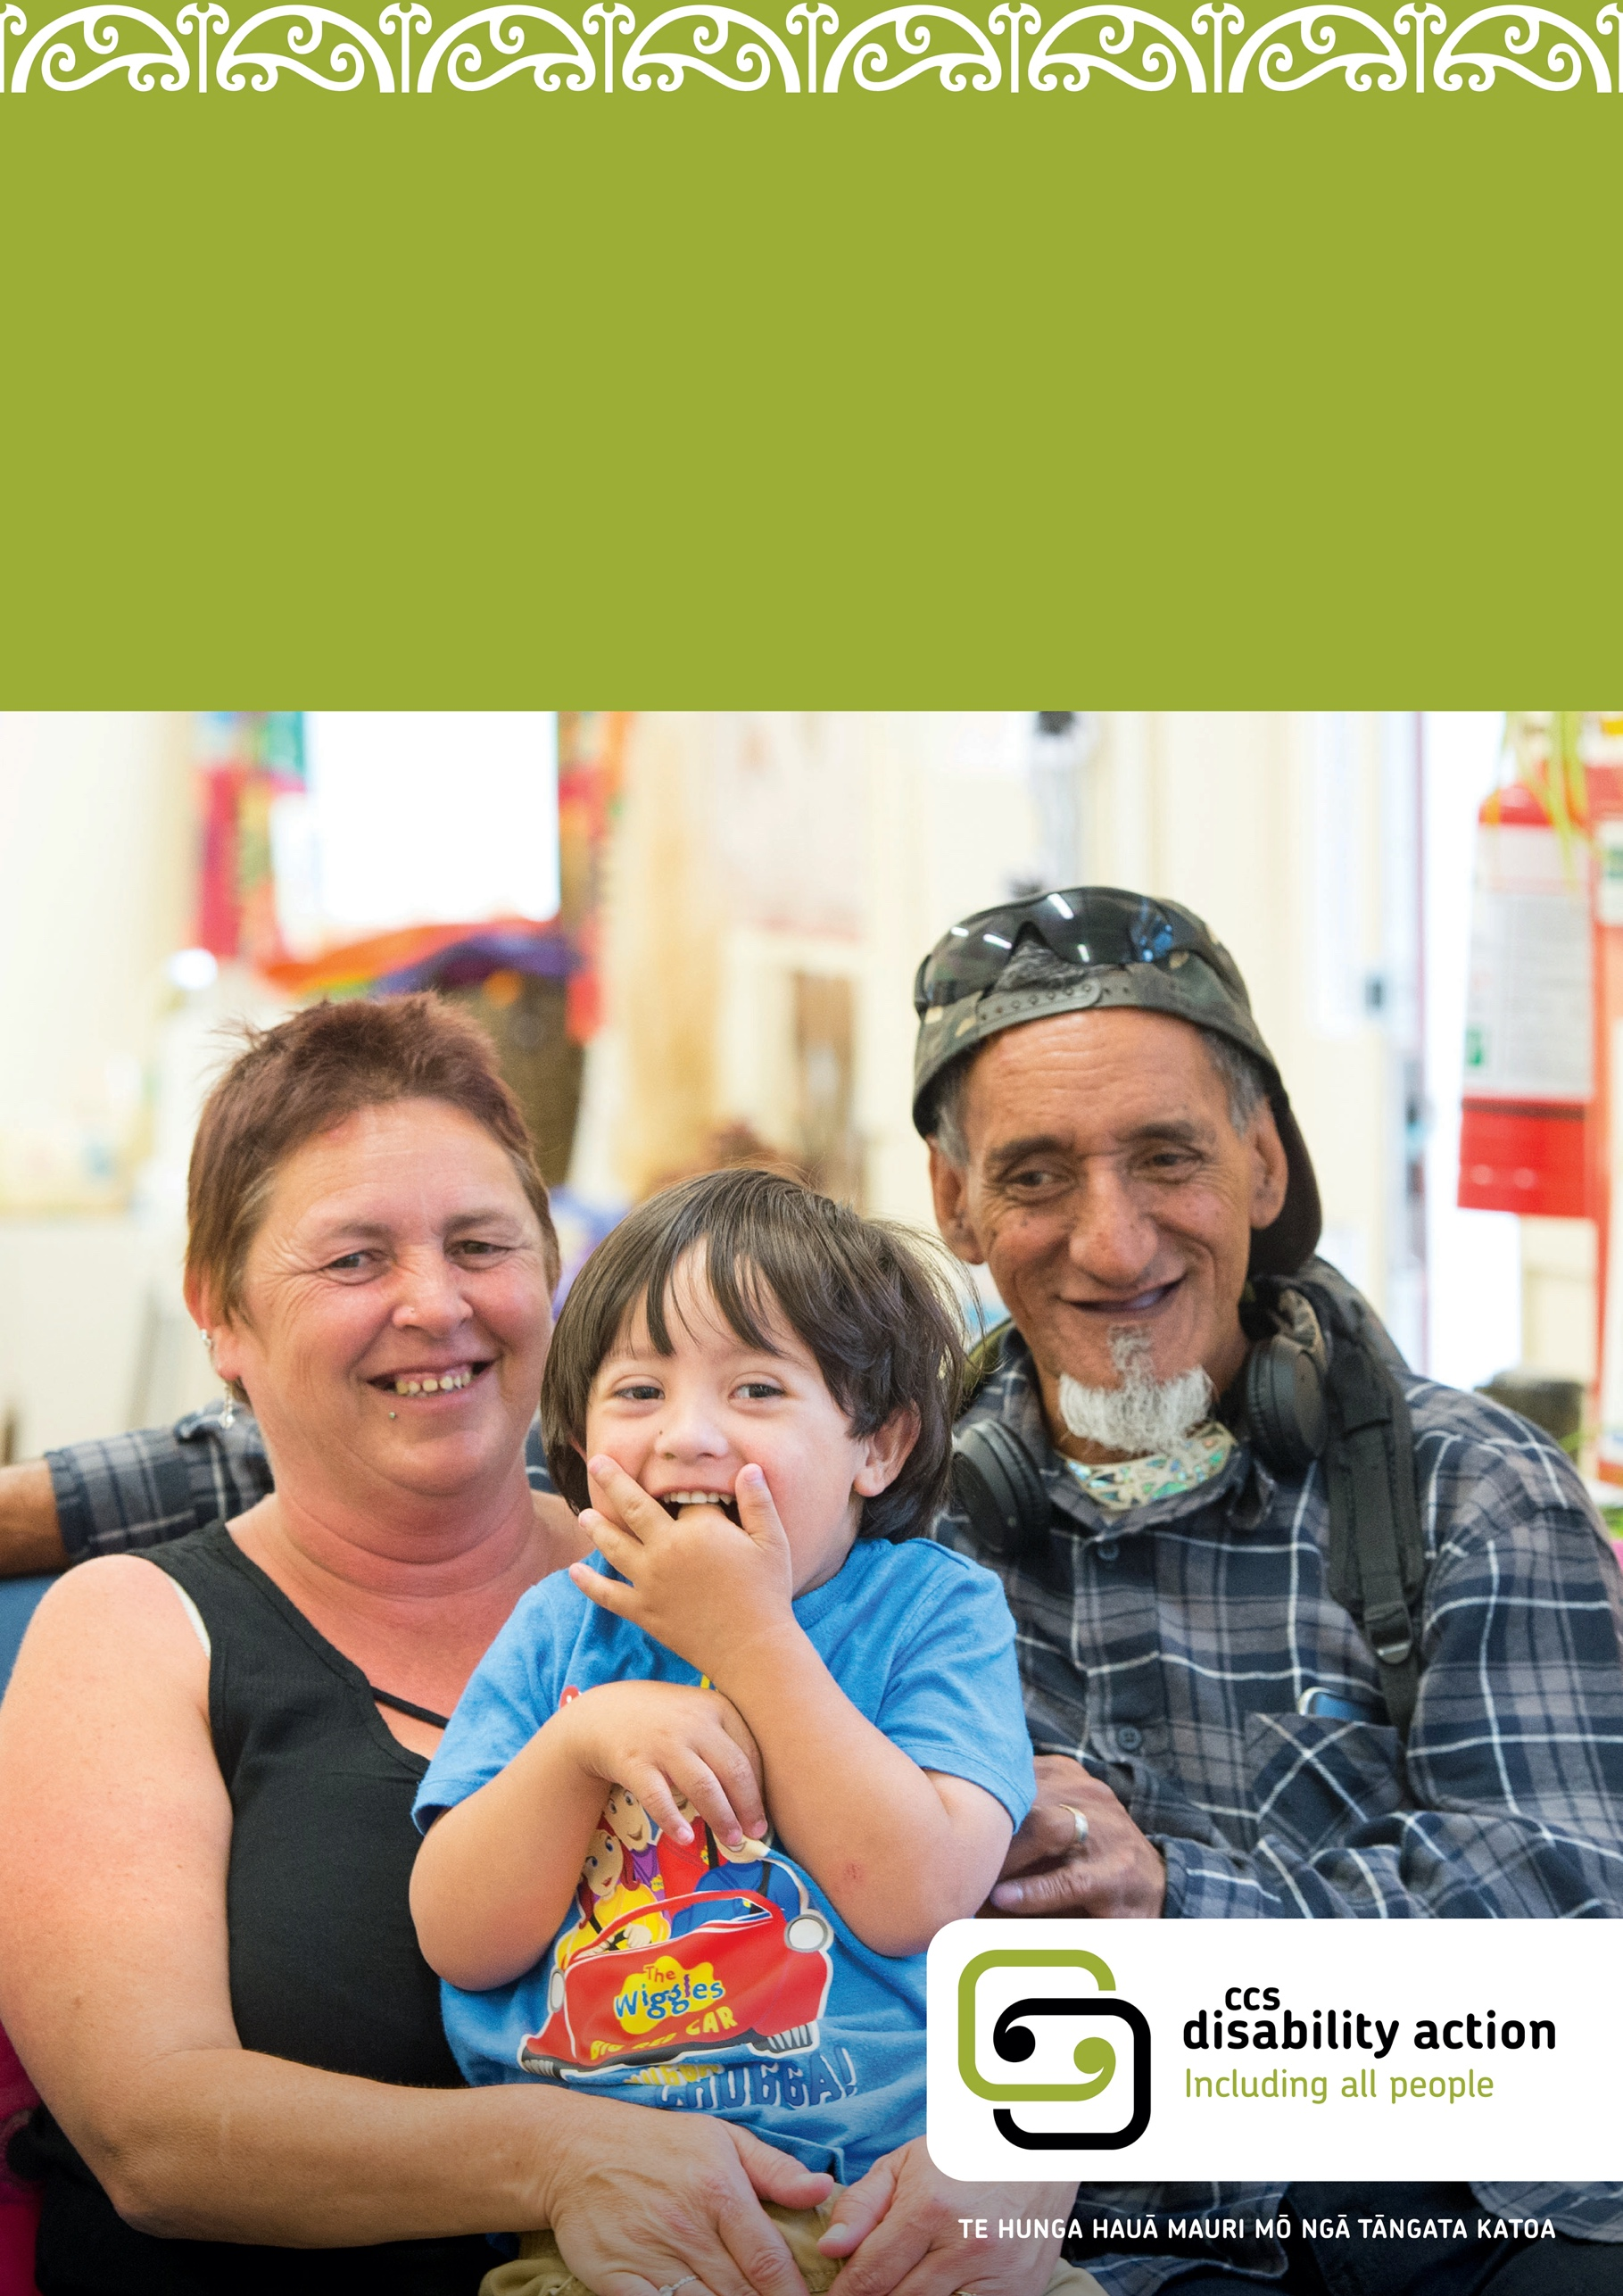
Caregiver
Training
Foster Caregivers training information

Caregiver Training Calendar

Introduction
The National Care Standards set out the standard of care every child and young person needs to do well and be well, and the support all caregivers can expect to receive when they open their hearts and homes to tamariki.
They came into effect on 1 July 2019.

National Care Standards
https://www.orangatamariki.govt.nz/children-in-our-care/national-care-standards/
Under Part Three, every Foster Caregiver is entitled to an assessment and support plan to help them meet the needs of children and young people in their care.
CCS Disability Action recognises that Foster Caregiving is a professional role that
requires a range of skills, knowledge and experience and that every child and young person being supported is unique and an individual, with individual needs. As a result, CCS Disability Action recommend that approved Foster Caregivers attend the following training, as a minimum, before their 2nd Support Plan (within the first year of being an approved caregiver):
- Welcome aboard training
- Service Coordinators will orient caregivers to CCS Disability Action policy and procedures, restraint, behaviour, medication, reimbursement
- First aid
- Crises prevention and intervention training
- Safeguarding and child protection
- Privacy ABC
Child specific training will be offered once a match is determined i.e., Epilepsy Awareness, Hoist, MiKey button feeding etc. These will be decided through a conversation between you as the caregiver and the coordinator supporting you in this placement.

Links for accessing support

First aid training
All CCS Disability Action caregivers need to have attend a first aid training prior to a child being placed in their care. Please see the links below and if there is a course you wish to attend please contact your CCS Disability Action coordinator and they will arrange
this for you.

Red Cross
https://first-aid.redcross.org.nz/book-course

St John
https://buy.stjohn.org.nz/firstaid/first-aid-courses/#?page=1&pageSize=9

Crisis prevention

Crisis Prevention Institute: MAPA Training – The Management of Actual or Potential Aggression (MAPA)
https://www.crisisprevention.com/en-NZ/Our-Programs/MAPA-Management-of-Actual-or-Potential-Aggression/Course-Topics-Foundation-Level

Understanding trauma and informed practice

Oranga Tamariki Ministry for Children
https://practice.orangatamariki.govt.nz/assets/resources/promoting-resilience-trauma-informed-practice-approach.pdf
https://practice.orangatamariki.govt.nz/practice-approach/theories-underpinning-our-work/trauma-informed-theory/#resources

Safeguarding child protection

Safeguarding Children
https://safeguardingchildren.org.nz/training

Caring for families

Caring families Aotearoa
https://www.caringfamilies.org.nz/foundations-for-attachment/
Caring for families offers:
Difficult Behaviours – Managing Confrontation and Intimidating Interactions
Fetal Alcohol Spectrum Disorder
Ako Ngātahi (Learning Together) – Parenting in a Healing Way
The Foundations for Attachment Training Program

Connecting the disabled community

Disability Connect
https://disabilityconnect.org.nz/information

Our vision
To help people with disabilities and their families to lead the lives they want.

Our mission
To empower disabled people and their families through leading social change.

Fetal alcohol spectrum disorder

FASD-CAN (Care Action Network)
https://www.fasd-can.org.nz
Online training and support courses for caregivers of children and youth with FASD.

Autism

Children’s Autism Foundation
https://www.autism.org.nz/what-we-do/workshops/
Modules available:
Understanding Autism
Sensory Issues
Dealing with Anxiety
Social Skills & Communication
Strategies for Behaviour

Pasifika Autism Support Group
http://www.asdpasifika.org.nz/
Pasifika Autism Support Group (PASG) meet once a term in a group meeting & every so often for ASD friendly family movie sessions.

Attention deficit hyperactivity disorder

ADHD New Zealand
https://www.adhd.org.nz

Our vision
To advance the ADHD community by providing practical information and support.

What we do
We connect people and organisations, enabling our members to collaborate on solutions and live with ADHD successfully. We inspire our members to succeed through learning events and sharing their stories. And we help them act through expert advice and support.

Online everyday with ADHD parenting evening course
Learn the “how to’s” for managing children with ADHD, learning disabilities and challenging behaviours.
Designed specifically for parents and carers, you'll be able to: decrease angry and aggressive behaviour, reduce stress and anxiety, provide tools for the child’s future, and recognise and encourage positive qualities.

By the conclusion of this course you would have established: understanding of your child, recognition of what you are really dealing with, re-engagement and relationship with your child, a positive view of your child, confidence in dealing with your child, confidence in dealing with your child’s school and education, and a bank of tools, strategies and resources for on-going future use.
Where: online – so you can do it from the comfort of your own home!
Dates: during the evenings of six Wednesdays.

Down syndrome

New Zealand Down Syndrome Association (NZSDA)
https://nzdsa.org.nz/
The New Zealand Down Syndrome Association (NZSDA) has set itself the mission to Support, inform and advocate alongside people with Down syndrome, families, whānau and professionals. The NZDSA works towards the vision that people with Down syndrome are respected, valued and equal members of their community fulfilling their potential and aspirations. NZDSA inform, support, educate and empower families/whānau and people with Down syndrome.

Auckland Down Syndrome Association Inc (ADSA)
https://adsa.org.nz/
The Auckland Down Syndrome Association Inc (ADSA) is a ADSA’s vision family/whanāu support organisation.
We believe all people are valued and contributing members of the community. ADSA works to support and promote the inclusion of people with Down syndrome in the community by providing information to people with Down syndrome, their families and carers. We also working on promoting: the rights and interests of people with Down syndrome, their families and carers, and a positive public awareness and attitude of Down syndrome in the community.
Success in School – We present our “Success in School: helping children who learn differently” course twice a year in March and August. This is a 2-day workshop. The course will start online at 8:45am and finish at approximately 2.30pm.

Cerebral palsy

Cerebral Palsy Guidance
https://www.cerebralpalsyguidance.com/cerebral-palsy/associated-disorders/
Cerebral palsy associated disorders are conditions that children with CP may develop. Almost all children with cerebral palsy have one or more health issues
Cerebral palsy online support groups give you the opportunity to branch out and get additional support in the comfort of your own home. Social networks connect people with similar interests and experiences and becoming especially popular.

Cerebral Palsy Society
https://cerebralpalsy.org.nz/
Enhancing the lives of people with Cerebral Palsy in New Zealand. Our mission is enabling people with cerebral palsy to maximise their potential.
See the website for a range of organisations and services are available to help New Zealanders living with Cerebral Palsy and other disabilities.
See the website for workshops, meetings and expos etc, held by the Cerebral Palsy Society, as well as disability organisations, charities and community groups around the country.
Coffee groups are a good way to connect with other members, socialise and make friends. The Cerebral Palsy Society currently has coffee groups running in a few regions around New Zealand, enabling members living with Cerebral Palsy to connect.

Cystic fibrosis

Cystic Fibrosis NZ
https://www.cfnz.org.nz/
Cystic fibrosis (CF) is the most common life threatening genetic condition affecting New Zealand children. It is a genetically inherited condition some people are born with that mainly affects their lungs and digestive system. We provide personalised support, including emotional guidance, practical advice or financial assistance, to individuals and their families with cystic fibrosis. As people live longer, and better, lives with cystic fibrosis, there are many life transitions, milestones and challenges to manage along the way. We support you and your family throughout your changing journey. We offer free, balanced information on all aspects of life with CF in our information resources and on our website. Along with the medical advice you receive from your CF team, our information can help you make informed decisions about your lifestyle, treatment and care, however you’re affected by cystic fibrosis.

Kidney issues

Kidney Kids NZ
https://kidneykids.org.nz/
Kidney Kids is a not-for-profit organisation that supports children, their families and whānau with kidney disease. We provide families with resources, information, family support events, personal development, hospital visits, home visits and other assistance. Through this, we support parents’ needs and support kidney kids to have the best possible experiences.
Camps and Events are run throughout the year.

Muscular dystrophy

Muscular Dystrophy New Zealand
https://www.mda.org.nz/

Our Vision
Freedom beyond limits.

Our Mission
Promoting freedom of choice and a responsive society.
Our regional branches also provide community level support for members with conditions and those close to them, offering camps and social events.

Deafness

Deaf Children New Zealand
https://deafchildren.org.nz/
Deaf Children New Zealand is a parent-led, volunteer organisation that supports parents and families of Deaf and Hard of Hearing Children. Our focus is on supporting parents, families and whānau, and ensuring that Deaf and Hard of Hearing children have appropriate access to the education curriculum and social experiences within the schooling environment.
Deaf Children NZ aims to host a Family Camp every second year in one of three locations; Christchurch, Wellington or Auckland. We have created a series of Information Sheets that you can read online or download to read and/or print.

Auckland Parents of Deaf Children
https://apodc.org.nz/
There are around 1,000 deaf children living in the Auckland area, including some
with additional physical and learning difficulties. 90% of deaf children are born into hearing families, and the majority attend mainstream school, where they may be the only
deaf child.
Deaf children face very real challenges associated with being in a world designed for hearing people. Communication difficulties and isolation are common experiences, which are also profoundly felt by families and whānau.
When deaf children, youth, and their families connect, things look very different. APODC helps them connect and provides social activities, support, advice and parental education.

Rare disorders

Rare Disorders NZ
https://www.raredisorders.org.nz/
RDNZ is the respected voice of rare disorders in New Zealand, and is the only national organisation supporting all New Zealanders who live with a rare condition, and the people who care for them.
RDNZ offers a platform and connector hub to link people to information and rare disorder groups specific to their disorder, and helps people navigate the health system and find a support group.

Williams syndrome

New Zealand Williams Syndrome Association
http://nzwsassociation.ning.com/
New Zealand Williams Syndrome Association NZWSA is a registered charity and a voluntary non-profit organization run by parents. The New Zealand Williams Syndrome Association offers help and support for families with a child or adult diagnosed with Williams Syndrome. We can put people in touch with other families similarly affected. We hold picnics and get togethers, sometimes with a speaker. Every two years we have a 3 day camp for the whole family. NZWSA has a small library of booklets, papers and videos on subjects relevant to WS. These are helpful for parents and teachers. Three newsletters a year are sent to members.

Blind/visual impairment

VICTA (Visual Impairment Charitable Trust Aotearoa NZ)
http://www.visualimpairment.org.nz/
VICTA is an energetic new charity established in 2013 to address the unmet needs of the growing number of New Zealanders with uncorrectable vision loss.

Blind Low Vision NZ
https://blindlowvision.org.nz/
We are New Zealand’s leading provider of vision rehabilitation, providing practical and emotional support for people with vision loss. Our vision rehabilitation services are personalised to meet your individual needs and goals, however big or small. To become a client, you need to register for our services. Once you’re set up, you’ll be able to access a wide range of support.
We support people with no or limited useful sight that makes doing day-to-day tasks a challenge, even with the best corrective lenses. Approximately three quarters of the people we work with have some vision (which we call low vision), and the remainder are blind.

Fostering and Residential Care

Research Centre for Better Outcomes from Fostering and Residential Care
(Better Outcomes)
https://www.betteroutcomes.org.nz/

About us and what we do
Better Outcomes is a New Zealand-based research centre and social enterprise; we exist to help organisations in New Zealand, Australia and internationally, to generate and use evidence and learning so that children and young people in or leaving out-of-home care (OOHC) can thrive.

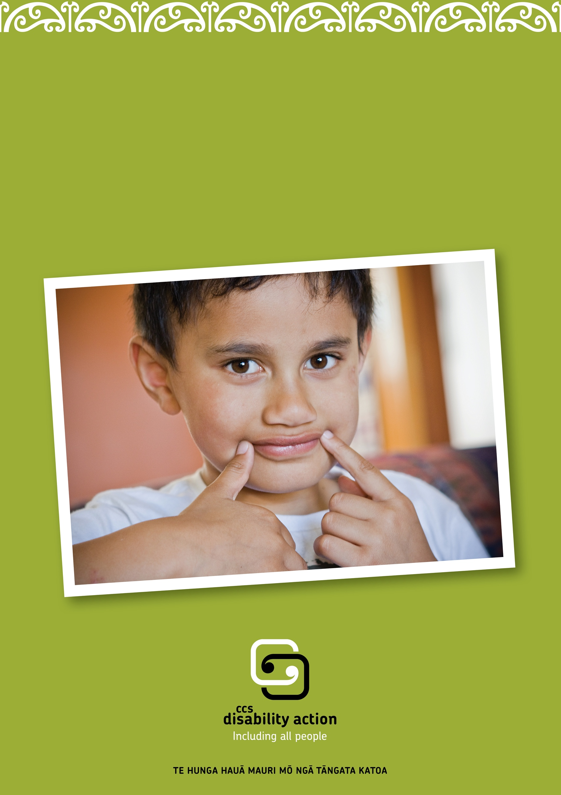
Get in touch
Whakapā mai
0800 227 200
Info@ccsDisabilityAction.org.nz
www.facebook.com/ccsDisabilityAction
@ccsdisabilityaction
www.ccsDisabilityAction.org.nz

